Skin Cancer Detection

Using

Transfer Learning

&

Ensemble Modelling

Under the Guidance of

**Dr. Agilandeeswari L**

(Associate Professor, School of Information Technology and Engineering)

For the Course

**ITE1015 – Soft Computing**

For Winter Semester 2020-21

**Project Team:**

Aashish Bansal 19BIT0346

Perumalla Sasank 19BIT0338

Keerthi Yasasvi 19BIT0335

**DECLARATION**

We, hereby, declare that the thesis entitled “Skin Cancer Detection Using Transfer Learning and Ensemble Modelling" submitted by us, for the award of the degree of *Bachelor of Technology in Information Technology* to VIT is a record of bonafide work carried out by me under the supervision of Dr. Agilandeeswari L.

We further declare that the work reported in this thesis has not been submitted and will not be submitted, either in part or in full, for the award of any other Degree or Diploma in this Institute or any other Institute or University.

Place: Vellore Date: 17th May 2021



**Signature of the Candidates**

# Acknowledgements

We would like to thank our mentor and the faculty in-charge for the course ITE1015 – Soft Computing, Dr. Agilandeeshwari L. for approving the project and being a mentor and guide for the project and helping us create, improve and bring out the best of our abilities to improve our skill and knowledge for learning, implementing and executing the project.

For the Project Team, we would to thank each other for helping each other in the hardships faced and sharing the joy of reaching a milestone and being a true support for each other at every step of the project. We had,

Aashish Bansal for Preparing and Training the Model and Documentation

Perumalla Sasank and Keerthi Yasasvi for Interface Development, Design and Documentation

# Executive Summary

Vellore Institute of Technology, Vellore

Faculty Name: Agilandeeshwari L.

10th May, 2021

## Executive Summary: Skin Cancer

Skin Cancer is categorized into two categories namely: malignant melanoma(lethal) and benign(non-lethal/treatable). Evolution in technology has brought upon many boon’s as well as banes and Cancer is one of them, skin cancer becoming a common side effect due to exposure to a lethal level of radiation or due to genetic disorder from exposure to radiation. The opportunity for machine learning models to be implemented, recommendations and costs are mentioned in this article.

## Opportunity

With boons of advancement in technology machine learning models can be implemented and trained to detect, diagnose and possibly prevent any benign case from turning into a malignant case thus, advancing the medical infrastructure. Currently the main challenges are the cost-effective models to train, economic viability and error detection rates varying from ethnicity/race and a few specific cases.

## Solution/recommendation

Training of a model with Mobilenet, Inception and Xception Architecture gives an economically viable solution and a detection rate of above 60% which as per the IEEE standards is viable for use practically. Recurring training of various Skin Cancer training data based on specific individuals with previously known other skin disorders and others on their race/ethnicity as to increase the detection rate without overfitting the model.

# table of Contents

Table of Contents

Acknowledgements 3

Executive Summary 4

Executive Summary: Skin Cancer 4

Opportunity 4

Solution/recommendation 4

table of Contents 5

Table of Figures 8

table of Tabular Information 10

Abbreviations 11

Symbols and Notations 12

Abstract 13

Introduction 14

Objective 14

Motivation 14

Background 14

About the Disease 15

Facts on Melanoma Skin Cancer 16

Statistics on Skin Cancer 17

Skin cancer rates: both Genders 17

Skin cancer rates in men 18

Skin cancer rates in women 19

Project Description and Goals 21

Technical Specifications 23

Model Development and Training 23

Interface Development and Testing 23

Interface Requirements 23

pLATFORM, cONFIGURATION AND sPECIFICATION 23

Design Approach and Details 24

Design Approach/Materials and Methods 24

Codes and Standards 24

Project Source Code 24

Source Code in the Form of a PY File 24

Source Code Screenshots in Colab 104

Proposed Architecture 170

Pre-processing 170

Training Model 172

Prediction 173

Evaluating the Models Individually on Validation Data 174

Evaluating the Models Together on Validation Data – Ensembling the Models 176

Evaluating the Models Individually on Testing Data 177

Evaluating the Models Together on Testing Data – Ensembling the Models 179

Localization 180

Saving the Complete Model for the Python Interface Application 181

Converting the .h5 File to .tflite File for the Python Interface APplication 181

Proposed Architecture Specifications 182

Data Selection 182

Backgraound 182

Melanoma 182

Dermoscopy 182

Exploratory Data Analysis 183

Checking the Types of Data 183

Finding the Outliers 183

Keep 183

Delete 184

Recode 184

Data Visualization 184

Data Pre-Processing 184

Splitting the Data 184

Underfitting: 184

overfitting? 184

Checking for Missing Values 184

Checking Categorical Features 185

Normalizing Dataset 185

Feature Transformation 185

Why do we need Feature Transformation and Scaling? 185

Feature Transformations used in the Models 185

Model Selection 186

Model Training 186

Project Demonstration 187

Application Interface 187

Mounting Google Drive 189

Loading and Display the CSV Dataset 189

Training CSV File 189

Validation CSV File 189

Testing CSV File 190

Converting the Data into Tensors 190

Training Tensor 190

Validation Tensor 190

Testing Tensor 190

Fitting into the Models 191

Predictions on a Sample Image 192

Evaluation of MobileNet on Validation Data 193

Evaluation of Inception on Validation Data 196

Evaluation of Xception on Validation Data 198

Evaluation of Models Together on Validation Data 200

Evaluating the Models Individually on Testing Data 204

MobileNet 204

Inception 207

Xception 209

Evaluating the Models Together on Testing Data - Ensembling the models 210

Localization 213

Saving the Complete Model for Python Interface Application 214

Converting the .h5 File to .tflite File for the Python Interface Application 214

Cost Analysis, Result and discussion 214

Summary 214

References 215

Websites 215

Concepts & Information 215

Research 216

# Table of Figures

Figure 1: MobileNet Architeure (Source: Analytics Vidya) 21

Figure 2: InceptionV3 Architecture (Source: Google Cloud) 22

Figure 3: Xception Architecture (Source: pyimagesearch.com) 22

Figure 4: Proposed Architecture - Pre-processing(i) 170

Figure 5: Proposed Architecture - Pre-processing(ii) 171

Figure 6: Proposed Architecture - Training Model 172

Figure 7: Proposed Architecture - Prediction Function 173

Figure 8: Proposed Architecture - Evaluating Models Individually on Validation Data (i) 174

Figure 9: Proposed Architecture - Evaluating the Models Individually on Validation Data (ii) 175

Figure 10: Proposed Architecture - Evaluating the Models Together on Validation Data 176

Figure 11: Proposed Architecture - Evaluating the Models Individually on Testing Data (i) 177

Figure 12: Proposed Architecture - Evaluating the Models Individually on Testing Data (ii) 178

Figure 13: Proposed Model - Evaluating the Models Together on Testing Data 179

Figure 14: Proposed Architecture - Localization 180

Figure 15: Proposed Architecture - Saving the Complete Model for the Application Interface 181

Figure 16: Converting the H5 File to TFLITE File for Application Interface 181

Figure 17: Sample Images of the Dataset 183

Figure 18: Visualizing a Tensor 186

Figure 19: First View of Interface 187

Figure 20: Selecting a File for Uploading 188

Figure 21: Display of Output 188

Figure 22: Project Demonstration - Mounting Google Drive for Authorization 189

Figure 23: Project Demonstration - Data in CSV File for Training Data 189

Figure 24: Project Demonstration - Data in CSV File for Validation Data 189

Figure 25: Project Demonstration - Data in CSV File for Testing Data 190

Figure 26: Project Demonstration - Converting Training Files to Tensors 190

Figure 27: Project Demonstration - Converting Validation Files to Tensors 190

Figure 28: Project Demonstration - Converting Testing Files to Tensors 190

Figure 29: Project Demonstration - Training the MobileNet Architecture 191

Figure 30: Project Demonstration - Training the Inception Architecture 191

Figure 31: Project Demonstration - Training the Xception Architecture 192

Figure 32: Project Demonstration - Predicting on a Sample Image using MobileNet 192

Figure 33: Project Demonstration - Predicting on a Sample Image using Inception 192

Figure 34: Project Demonstration - Predicting on a Sample Image using Xception 193

Figure 35: Project Demonstration - Evaluation of MobileNet on Training Data - Confusion Matrix 193

Figure 36: Project Demonstration - Evaluation of MobileNet on Training Data - Obtaining Labels 194

Figure 37: Project Demonstration - Evaluation of MobileNet on Training Data(i) 195

Figure 38: Project Demonstration - Evaluation of MobileNet on Training Data(ii) 195

Figure 39: Project Demonstration - Evaluation of Inception on Training Data - Confusion Matrix 196

Figure 40: Project Demonstration - Evaluation of Inception on Training Data(i) 197

Figure 41: Project Demonstration - Evaluation of Inception on Training Data(ii) 197

Figure 42: Project Demonstration - Evaluation of Xception on Training Data - Confusion Matrix 198

Figure 43: Project Demonstration - Evaluation of Xception on Training Data(i) 199

Figure 44: Project Demonstration - Evaluation of Xception on Training Data (ii) 199

Figure 45: Project Demonstration - Evaluation of Models Together on Validation Data - Defining Ensemble Function 200

Figure 46: Project Demonstration - Evaluation of Models Together on Validation Data - Loading all Model Weights 200

Figure 47: Project Demonstration - Evaluation of Models Together on Validation Data - Serializing Weights into one 200

Figure 48: Project Demonstration - Evaluation of Models Together on Validation Data - Computing Test Set Predictions 201

Figure 49: Project Demonstration - Evaluation of Models Together on Validation Data - Obtaining Labels 202

Figure 50: Project Demonstration - Evaluation of Models Together on Validation Data(i) 203

Figure 51: Project Demonstration - Evaluation of Models Together on Validation Data(ii) 203

Figure 52: Project Demonstration - Evaluation of MobileNet Model Individually on Testing Data - Confusion Matrix 204

Figure 53: Project Demonstration - Evaluation of MobileNet Model Individually on Testing Data - Obtaining Labels 205

Figure 54: Project Demonstration - Evaluation of MobileNet Model Individually on Testing Data(i) 206

Figure 55: Project Demonstration - Evaluation of MobileNet Model Individually on Testing Data(ii) 206

Figure 56: Project Demonstration - Evaluation of Inception Model Individually on Testing Data - Confusion Matrix 207

Figure 57: Project Demonstration - Evaluation of Inception Model Individually on Testing Data(i) 208

Figure 58: Project Demonstration - Evaluation of Inception Model Individually on Testing Data(ii) 208

Figure 59: Project Demonstration - Evaluation of Xception Model Individually on Testing Data - Obtaining Labels 209

Figure 60: Project Demonstration - Evaluation of Xception Model Individually on Testing Data(i) 210

Figure 61: Project Demonstration - Evaluation of Xception Model Individually on Testing Data(ii) 210

Figure 62: Project Demonstration - Evaluation of Models Together on a Sample Image 210

Figure 63: Project Demonstration - Evaluation of Models Together - Obtaining the Labels 211

Figure 64: Project Demonstration - Evaluation of Models Together on Metrics(i) 212

Figure 65: Project Demonstration - Evaluation of Models Together on Metrics(ii) 212

Figure 66: Project Demonstration - Localization - Visualizing Images 213

Figure 67: Project Demonstration - Localization - Display of Result 213

Figure 68: Project Demonstration - Saving the Model for Application Interface 214

Figure 69: Project Demonstration - Converting the H5 File to TFLITE File 214

# table of Tabular Information

Table 1: Skin Cancer Rates: Both Gender 17

Table 2: Skin Cancer Rates in Men 18

Table 3: Skin Cancer Rates in Women 19

# Abbreviations

* CNN – Convolution Neural network
* GUI – Graphics User interface
* UV light – Ultra Violet light
* OS – Operating System
* ResNet – Residential Energy Services Network
* CSV – Comma Separated Values
* ROC – Receiver Operating Circuit
* EDA – Exploratory Data Analysis
* MCAR - Missing Completely At Random
* MAR - Missing At Random
* MNAR - Missing Not at Random
* ISIC – international Standard industrial classification
* SIIM – Society for Imaging Informatics in Medicine
* U.S. – United States of America
* SPF – Sun Protection Factors
* Exe File – Executable File
* VGG - Visual Geometry Group
* ROC - Receiving Operating Characteristic Curve
* EDA – Exploratory Data Analysis
* np – Numpy
* 4D – Four Dimensional
* ML – Machine Learning
* H5 - Hierarchical Data Format
* TFLITE – Tensorflow Lite
* API – Application Programming Interface

# Symbols and Notations

|  |  |
| --- | --- |
| Symbol | Meaning |
| - | Subtraction |
| + | Addition |
| / | Division |
| ()/x | Multiplication (multiplication of enclosed value and value outside the enclosed bracket) |

Skin Cancer Detection using Transfer Learning and Ensemble Modeling

Proposed Architecture

# Abstract

The project is a Transfer Learning and Ensemble Learning trained model which consists of the MobileNet, Inception and Xception Learning pre-trained Models which can predict whether the patient has a suffering from Skin Cancer or not by checking the scanning and predicting on the images of the infected areas on the body. The model has been trained on a variety of images through which it predicts the required.

In this project, the image file of the patient is upload into a general public use software, which is a GUI-based interface, developed with the help of Tkinter and Python, and it consists of the model saved as a file and the software passes the image through the function and uses the results obtained that to analyse the image and give the prediction which can help people and doctors to start with the medication way earlier instead of waiting for the laboratory tests and reports for the confirmation, which are also very expensive.

We know about Skin Cancer that Skin cancer is an abnormal growth of skin cells. Most skin cancers are caused by exposure to ultraviolet (UV) light. When the skin is not protected, UV rays from sunlight or tanning beds can damage and alter skin's DNA that leads to the cancer.

Now, Deep learning model has been built to classify and identify the binary diagnostic group of melanocytic images obtained through dermoscopy. And based on the model, disease detection through dermal cell images has been investigated, and classifications on dermal cell images have been performed.

# Introduction

## Objective

In this project, we plan on taking the image of the skin disease of a patient and upload and pass it through the machine learning model which we have created and and based on the analysis of the image by the model, we plan on predicting whether the person is suffering from Skin Cancer or not.

We intent to make a free software in the interest of the benefit of the general public and can be used by anyone and everyone and they can use it to check for the possibility of Skin Cancer with the ease of being at there home by uploading a clear image of the infected area.

The image file of the patient is upload into a software, which is GUI-based interface, developed with the help of Tkinter, and it consists of the model saved as a file and the software uses that to analyse the image and give the prediction which can help doctors to start with the medication way faster instead of waiting for the laboratory reports for the confirmation.

## Motivation

Skin cancer is an alarming disease for mankind. The necessity of early diagnosis of the skin cancer have been increased because of the rapid growth rate of Melanoma skin cancer, its high treatment costs, and death rate. This cancer cells are detected manually and it takes time to cure in most of the cases. We even intend to help people in the pandemic time so that people do not have to risk there lives on getting the laboratory tests.

The features of the affected skin cells are extracted after the segmentation of the dermoscopic images using feature extraction technique.

We want to build an application which we can deploy in the production for the general public and can be used by anyone and everyone for their benefit to start early with the medication and precautions.

## Background

Skin cancer is an abnormal growth of skin cells. Most skin cancers are caused by exposure to ultraviolet (UV) light. When the skin is not protected, UV rays from sunlight or tanning beds can damage and alter skin's DNA that leads to the cancer.

Deep learning model has been built to classify and identify the binary diagnostic group of melanocytic images obtained through dermoscopy. Based on the model, disease detection through dermal cell images has been investigated, and classifications on dermal cell images have been performed.

# About the Disease

Skin cancer is the most prevalent type of cancer. Melanoma, specifically, is responsible for 75% of skin cancer deaths, despite being the least common skin cancer. The American Cancer Society estimates over 100,000 new melanoma cases will be diagnosed in 2020. It's also expected that almost 7,000 people will die from the disease. As with other cancers, early and accurate detection—potentially aided by data science—can make treatment more effective.

Currently, dermatologists evaluate every one of a patient's moles to identify outlier lesions or “ugly ducklings” that are most likely to be melanoma. Existing AI approaches have not adequately considered this clinical frame of reference. Dermatologists could enhance their diagnostic accuracy if detection algorithms take into account “contextual” images within the same patient to determine which images represent a melanoma. If successful, classifiers would be more accurate and could better support dermatological clinic work.

As the leading healthcare organization for informatics in medical imaging, the Society for Imaging Informatics in Medicine (SIIM)'s mission is to advance medical imaging informatics through education, research, and innovation in a multi-disciplinary community. SIIM is joined by the International Skin Imaging Collaboration (ISIC), an international effort to improve melanoma diagnosis. The ISIC Archive contains the largest publicly available collection of quality-controlled dermoscopic images of skin lesions.

In this competition, you’ll identify melanoma in images of skin lesions. In particular, you’ll use images within the same patient and determine which are likely to represent a melanoma. Using patient-level contextual information may help the development of image analysis tools, which could better support clinical dermatologists.

Melanoma is a deadly disease, but if caught early, most melanomas can be cured with minor surgery. Image analysis tools that automate the diagnosis of melanoma will improve dermatologists' diagnostic accuracy. Better detection of melanoma has the opportunity to positively impact millions of people.

# Facts on Melanoma Skin Cancer

* It’s estimated that the number of new melanoma cases diagnosed in 2021 will increase by 5.8 percent.
* The number of melanoma deaths is expected to increase by 4.8 percent in 2021.
* An estimated 207,390 cases of melanoma will be diagnosed in the U.S. in 2021. Of those, 106,110 cases will be in situ (non-invasive), confined to the epidermis (the top layer of skin), and 101,280 cases will be invasive, penetrating the epidermis into the skin’s second layer (the dermis). Of the invasive cases, 62,260 will be men and 43,850 will be women.
* In the past decade (2011 – 2021), the number of new invasive melanoma cases diagnosed annually increased by 44 percent
* An estimated 7,180 people will die of melanoma in 2021. Of those, 4,600 will be men and 2,580 will be women.
* The vast majority of melanomas are caused by the sun. In fact, one UK study found that about 86 percent of melanomas can be attributed to exposure to ultraviolet (UV) radiation from the sun.
* Compared with stage I melanoma patients treated within 30 days of being biopsied, those treated 30 to 59 days after biopsy have a 5 percent higher risk of dying from the disease, and those treated more than 119 days after biopsy have a 41 percent higher risk.
* Across all stages of melanoma, the average five-year survival rate in the U.S. is 93 percent. The estimated five-year survival rate for patients whose melanoma is detected early is about 99 percent. The survival rate falls to 66 percent when the disease reaches the lymph nodes and 27 percent when the disease metastasizes to distant organs.
* Only 20 to 30 percent of melanomas are found in existing moles, while 70 to 80 percent arise on apparently normal skin.
* On average, a person’s risk for melanoma doubles if they have had more than five sunburns, but just one blistering sunburn in childhood or adolescence more than doubles a person’s chances of developing melanoma later in life.
* Regular daily use of an SPF 15 or higher sunscreen reduces the risk of developing melanoma by 50 percent.
* Melanoma accounts for 6 percent of new cancer cases in men, and 5 percent of new cancer cases in women.
* Men age 49 and under have a higher probability of developing melanoma than any other cancer.
* From ages 15 to 39, men are 55 percent more likely to die of melanoma than women in the same age group.
* Women age 49 and under are more likely to develop melanoma than any other cancer except breast and thyroid cancers.
* From age 50 on, significantly more men develop melanoma than women. The majority of people who develop melanoma are white men over age 55. But until age 49, significantly more non-Hispanic white women develop melanoma than white men (one in 156 women versus one in 230 men). Overall, one in 27 white men and one in 40 white women will develop melanoma in their lifetime.

# Statistics on Skin Cancer

## Skin cancer rates: both Genders

Australia had the highest rate of melanoma in 2018, followed by New Zealand.

Table 1: Skin Cancer Rates: Both Gender

|  |  |  |
| --- | --- | --- |
| Rank | Country | Age-standardised rate per 100,000 |
| 1 | Australia | 33.6 |
| 2 | New Zealand | 33.3 |
| 3 | Norway | 29.6 |
| 4 | Denmark | 27.6 |
| 5 | Netherlands | 25.7 |
| 6 | Sweden | 24.7 |
| 7 | Germany | 21.6 |
| 8 | Switzerland | 21.3 |
| 9 | Belgium | 19.9 |
| 10 | Slovenia | 18.6 |
| 11 | Luxembourg | 16.5 |
| 12 | Ireland | 16.3 |
| 13 | Finland | 15.8 |
| 14 | UK | 15.0 |
| 15= | Austria | 13.6 |
| 15= | France (metropolitan) | 13.6 |
| 17 | US | 12.7 |
| 18 | Czech Republic | 12.6 |
| 19= | Canada | 12.4 |
| 19= | Italy | 12.4 |

## Skin cancer rates in men

Australia had the highest rate of melanoma in men in 2018, followed by New Zealand.

Table 2: Skin Cancer Rates in Men

|  |  |  |
| --- | --- | --- |
| Rank | Country | Age-standardised rate per 100,000 |
| 1 | Australia | 40.4 |
| 2 | **New Zealand** | **35.8** |
| 3 | Norway | 29.0 |
| 4 | **Netherlands** | **26.4** |
| 5 | Sweden | 23.5 |
| 6 | **Switzerland** | **23.4** |
| 7 | Denmark | 22.4 |
| 8 | **Germany** | **19.6** |
| 9 | Luxembourg | 18.1 |
| 10 | **Slovenia** | **18.0** |
| 11= | Belgium | 16.2 |
| 11= | **Finland** | **16.2** |
| 13= | Austria | 15.0 |
| 13= | **UK** | **15.0** |
| 15 | US | 14.9 |
| 16 | **France (metropolitan)** | **14.4** |
| 17 | Italy | 14.0 |
| 18 | **Ireland** | **13.6** |
| 19 | Canada | 13.4 |
| 20 | **Czech Republic** | **13.3** |

## Skin cancer rates in women

Denmark had the highest rate of melanoma in women in 2018, followed by New Zealand.

Table 3: Skin Cancer Rates in Women

|  |  |  |
| --- | --- | --- |
| Rank | Country | Age-standardised rate per 100,000 |
| 1 | Denmark | 33.1 |
| 2 | New Zealand | 31.1 |
| 3 | Norway | 30.7 |
| 4 | Australia | 27.5 |
| 5 | Sweden | 26.2 |
| 6 | Netherlands | 25.4 |
| 7 | Germany | 24.0 |
| 8 | Belgium | 23.9 |
| 9 | Slovenia | 19.7 |
| 10 | Switzerland | 19.5 |
| 11 | Ireland | 19.0 |
| 12 | Finland | 15.9 |
| 13 | Luxembourg | 15.4 |
| 14 | UK | 15.3 |
| 15 | France (metropolitan) | 12.9 |
| 16 | Austria | 12.6 |
| 17 | Czech Republic | 12.4 |
| 18= | Canada | 11.7 |
| 18= | Iceland | 11.7 |
| 20 | Estonia | 11.4 |
| 21= | Italy | 11.0 |
| 21= | US | 11.0 |
| 23 | Greece | 10.3 |
| 24 | Hungary | 10.1 |
| 25 | Lithuania | 9.0 |

# Project Description and Goals

As mentioned before, in this project, the image file of the patient is upload into a software, which is GUI-based interface, developed with the help of Tkinter, and it consists of the model saved as a file and the software uses that to analyze the image and give the prediction which can help doctors to start with the medication way faster instead of waiting for the laboratory reports for the confirmation.

The learning model is created with the help of the following pre-trained architectures: MobileNet, Inception and Xception.

The MobileNet Architecture is based on a streamlined architecture that uses a depth-wise separable convolution to build a light-weight deep neural network. We introduce two simple global hyper-parameters that efficiently trade off between latency and accuracy. These hyper-parameters allow the model builder to choose the right sized model for their application based on the constraints of the problem.

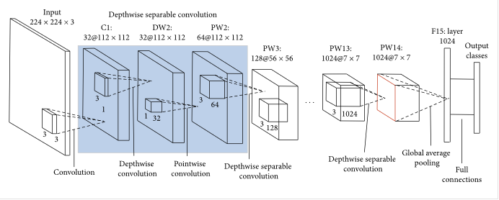

Figure 1: MobileNet Architeure (Source: Analytics Vidya)

The model is the culmination of many ideas developed by multiple researchers over the years. It is based on the original paper: ["Rethinking the Inception Architecture for Computer Vision"](https://arxiv.org/abs/1512.00567) by Szegedy, et. al.

The model itself is made up of symmetric and asymmetric building blocks, including convolutions, average pooling, max pooling, concats, dropouts, and fully connected layers. Batchnorm is used extensively throughout the model and applied to activation inputs. Loss is computed via Softmax.

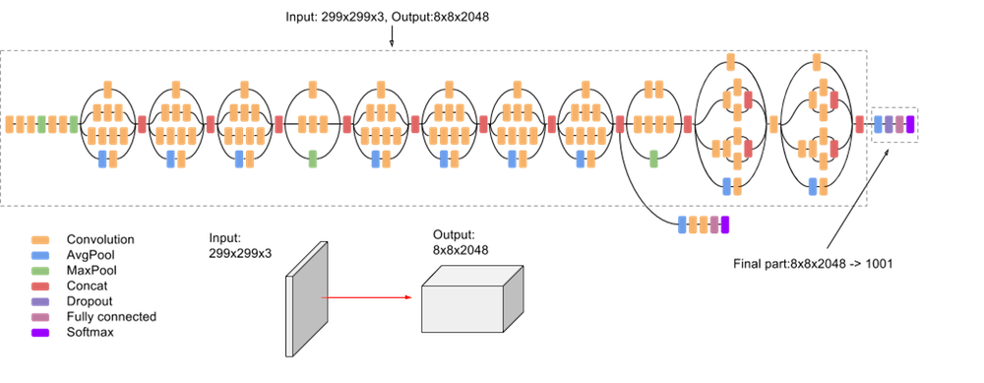

Figure 2: InceptionV3 Architecture (Source: Google Cloud)

Xception stands for “extreme inception.” Rather like our previous two architectures, it reframes the way we look at neural nets — conv nets in particular. And, as the name suggests, it takes the principles of Inception to an extreme. Here’s the hypothesis: “*cross-channel correlations and spatial correlations are sufficiently decoupled that it is preferable not to map them jointly*.”

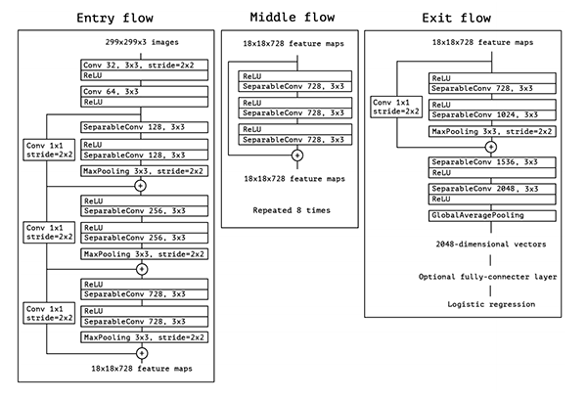

Figure 3: Xception Architecture (Source: pyimagesearch.com)

The goal of this project is in the favour of the help of the general public as anyone and everyone can use this to check personally so that the medications and precautions can be started early.

# Technical Specifications

## Model Development and Training

Development of the Machine Learning/Deep Learning Model requires the knowledge and skill of using Jupyter Notebook (either installed via Anaconda Studio or directly as an individual component) or Google Colab along with high-powered Graphical Processing Unit for better, reduced and efficient processing time.

Use of Google Colab gives more advantages for writing and execution of code in Python, sharing notebook, Integrating Libraries and Dependencies and also to increase the available processing power through Cloud Computing. The advantage of Cloud Computing allows the model to still train even if the system crashes due to some unforeseen reason and does not cause a halt to the training.

## Interface Development and Testing

The interface is converted into an executable file (exe File) so that the general public regardless of with or without any technical skills can simply install the software on their system and use the model to check if the patient suffering from the disease has Skin Cancer or not, so that the patient can think and take action at an early stage and start with the precautions and medications which can help save his/her life.

After uploading an image of the infected area, the final result is that whether the person is suffering from skin cancer or not. The final result is shown through an alert box.

## Interface Requirements

There are two interfaces namely – User Interface and Software Interface.

* User Interface: The user interface will be implemented using any desktop running on Windows OS. This interface will be very user friendly so that people from different strata can use it to detect their disease without any difficulty by just uploading their medical test image.
* Software Interface: A software interface running on Windows OS. It should have Python compiler.

## pLATFORM, cONFIGURATION AND sPECIFICATION

**Platform:** Google Colab (Pro version recommended)

**Standard RAM:** 12.69 GB

**High-RAM Configuration:** 25.46 GB (recommended with Pro version)

**Normal Disk Space:** 89.15 GB

**Pro Version Disk Space:** 147.15 GB

**Engine:** Google 3 Python Compute Engine backed (GPU)

**GPU:** NVIDIA Tesla K80

# Design Approach and Details

## Design Approach/Materials and Methods

As suggested by the mentor to use the pre-trained models, for example, VGG, ResNet, MobileNet, etc., we planned on using these models and building an architecture. The proposed model includes the use of MobileNet, Inception and Xception model which are very well-known pre-trained architectures. These architectures have been brought together using Ensemble Modelling in which we have created a list of these models through which we join the Neural Net and further join their weights for one single model and to used and updated.

## Codes and Standards

For the implementation of this model, the code was written using the programming language Python. Python also has several advantages due to its hundreds of open-source libraries which are available for almost every functionality to improve and increase the performance. The program for interface is also written using Python.

# Proposed Architecture

## Pre-processing

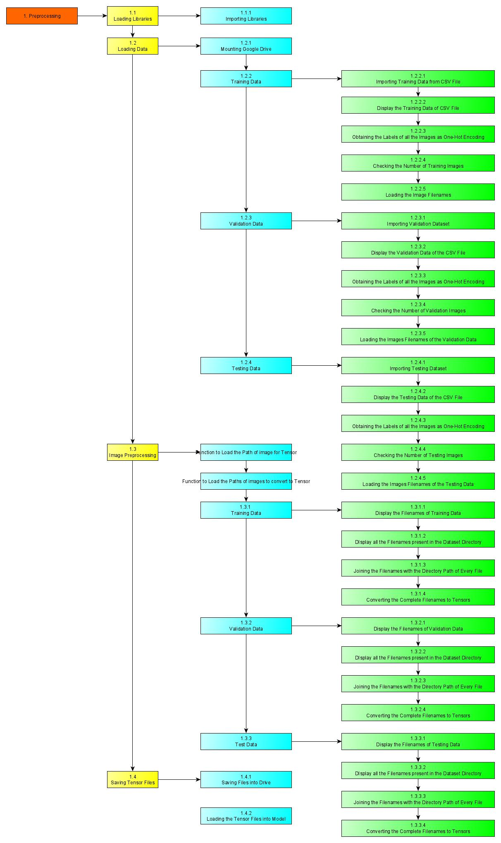

Figure 4: Proposed Architecture - Pre-processing(i)



Figure 5: Proposed Architecture - Pre-processing(ii)

All the required libraries are first loaded into the model and then the dataset is also loaded into the model using the Google Drive as the Dataset has been uploaded to the Google Drive it can be accessed directly through it.

After the Google Drive is connected and authorised for use, the CSV files of the Training, Validation and Testing Data are read one-by-one and the data which they contain is displayed. Further, it is required for the dataset images to have their directory location attached to the filenames because then the images can be accessed directly with it without changing the directory which might interrupt any further operation.

After the directory locations are attached to the filenames, the images are loaded into the model one-by-one and they are converted into tensors. After obtaining the tensors, they are stored in a separate location so that these tensors can be used directly and it eliminates the need for loading the dataset and processing it again and again and instead these tensor files can just be loaded into the model and used for further training and processing. This also saves a lot of time because we do not need to create the tensors again and again as the tensors will be same each time they are being created because it is the same images which might be used during the development of the project.

## Training Model

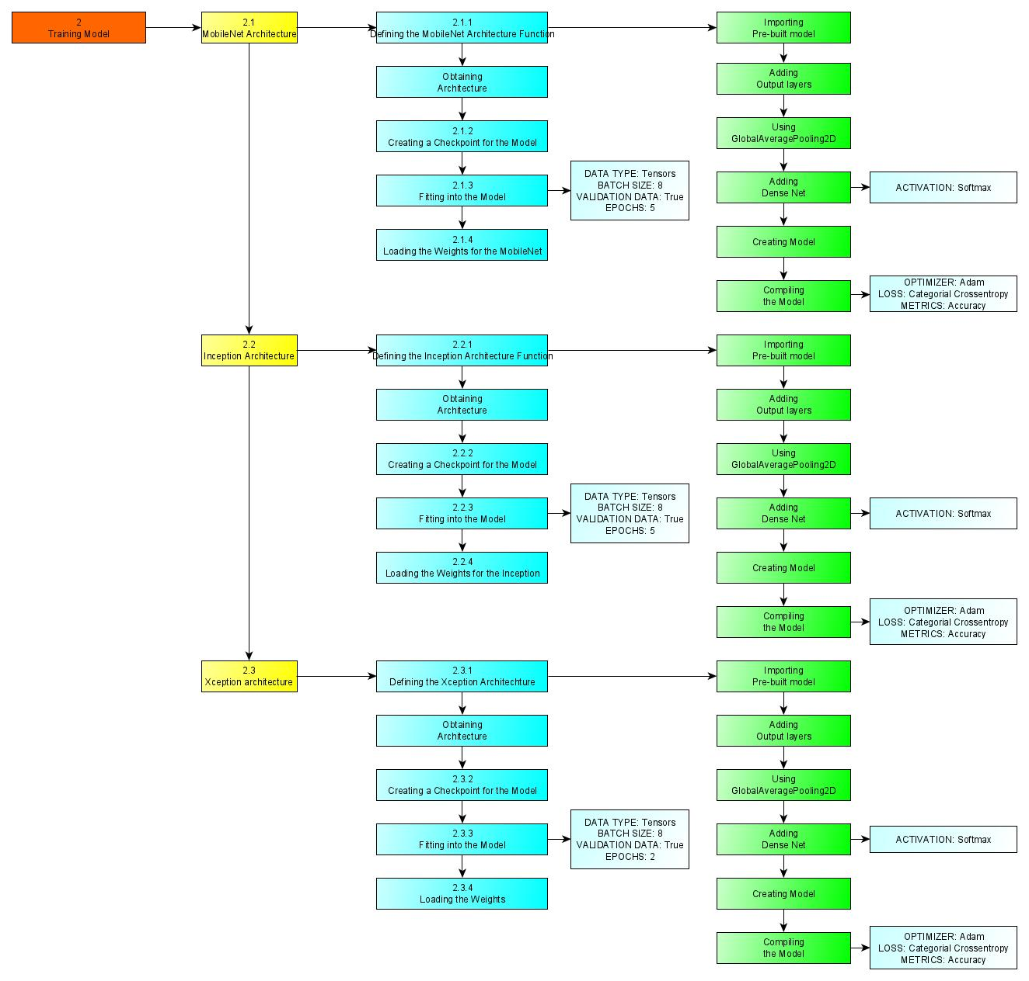

Figure 6: Proposed Architecture - Training Model

For this, we have used Transfer Learning and Ensemble Modelling. For the Transfer Learning, we have used the following pre-trained models:

* MobileNet Architecture
* InceptionV3 Architecture
* Xception Architecture

For the training, the pre-trained models are first loaded in as a function and then a since we have a checkpoint of these models, so we can start training these models from that checkpoint again. We start training it further by fitting it on the data which we have using the tensors.

## Prediction

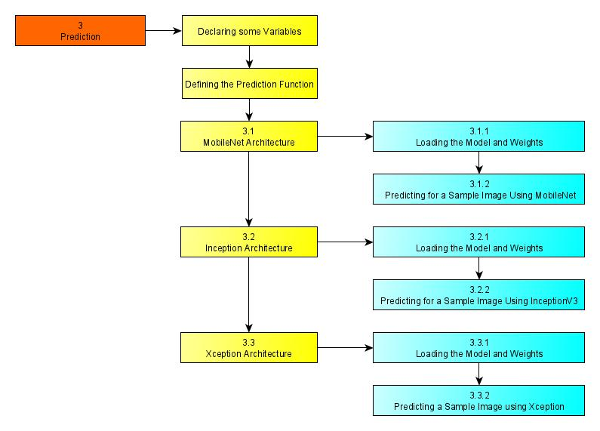

Figure 7: Proposed Architecture - Prediction Function

This prediction is done on a sample image just to check that all the models are working and are predicting. Working of this section denotes that the model can be taken to the further stage of evaluation of the validation data and the testing data.

For this part, we take the sample image and convert that image into a tensor. After that, the Individual Models and their respective weights are loaded so that the prediction can be made using the predictive function which we have defined. This is the function which will also be used for the Interface Application for the prediction on the image which will be uploaded by the user.

## Evaluating the Models Individually on Validation Data

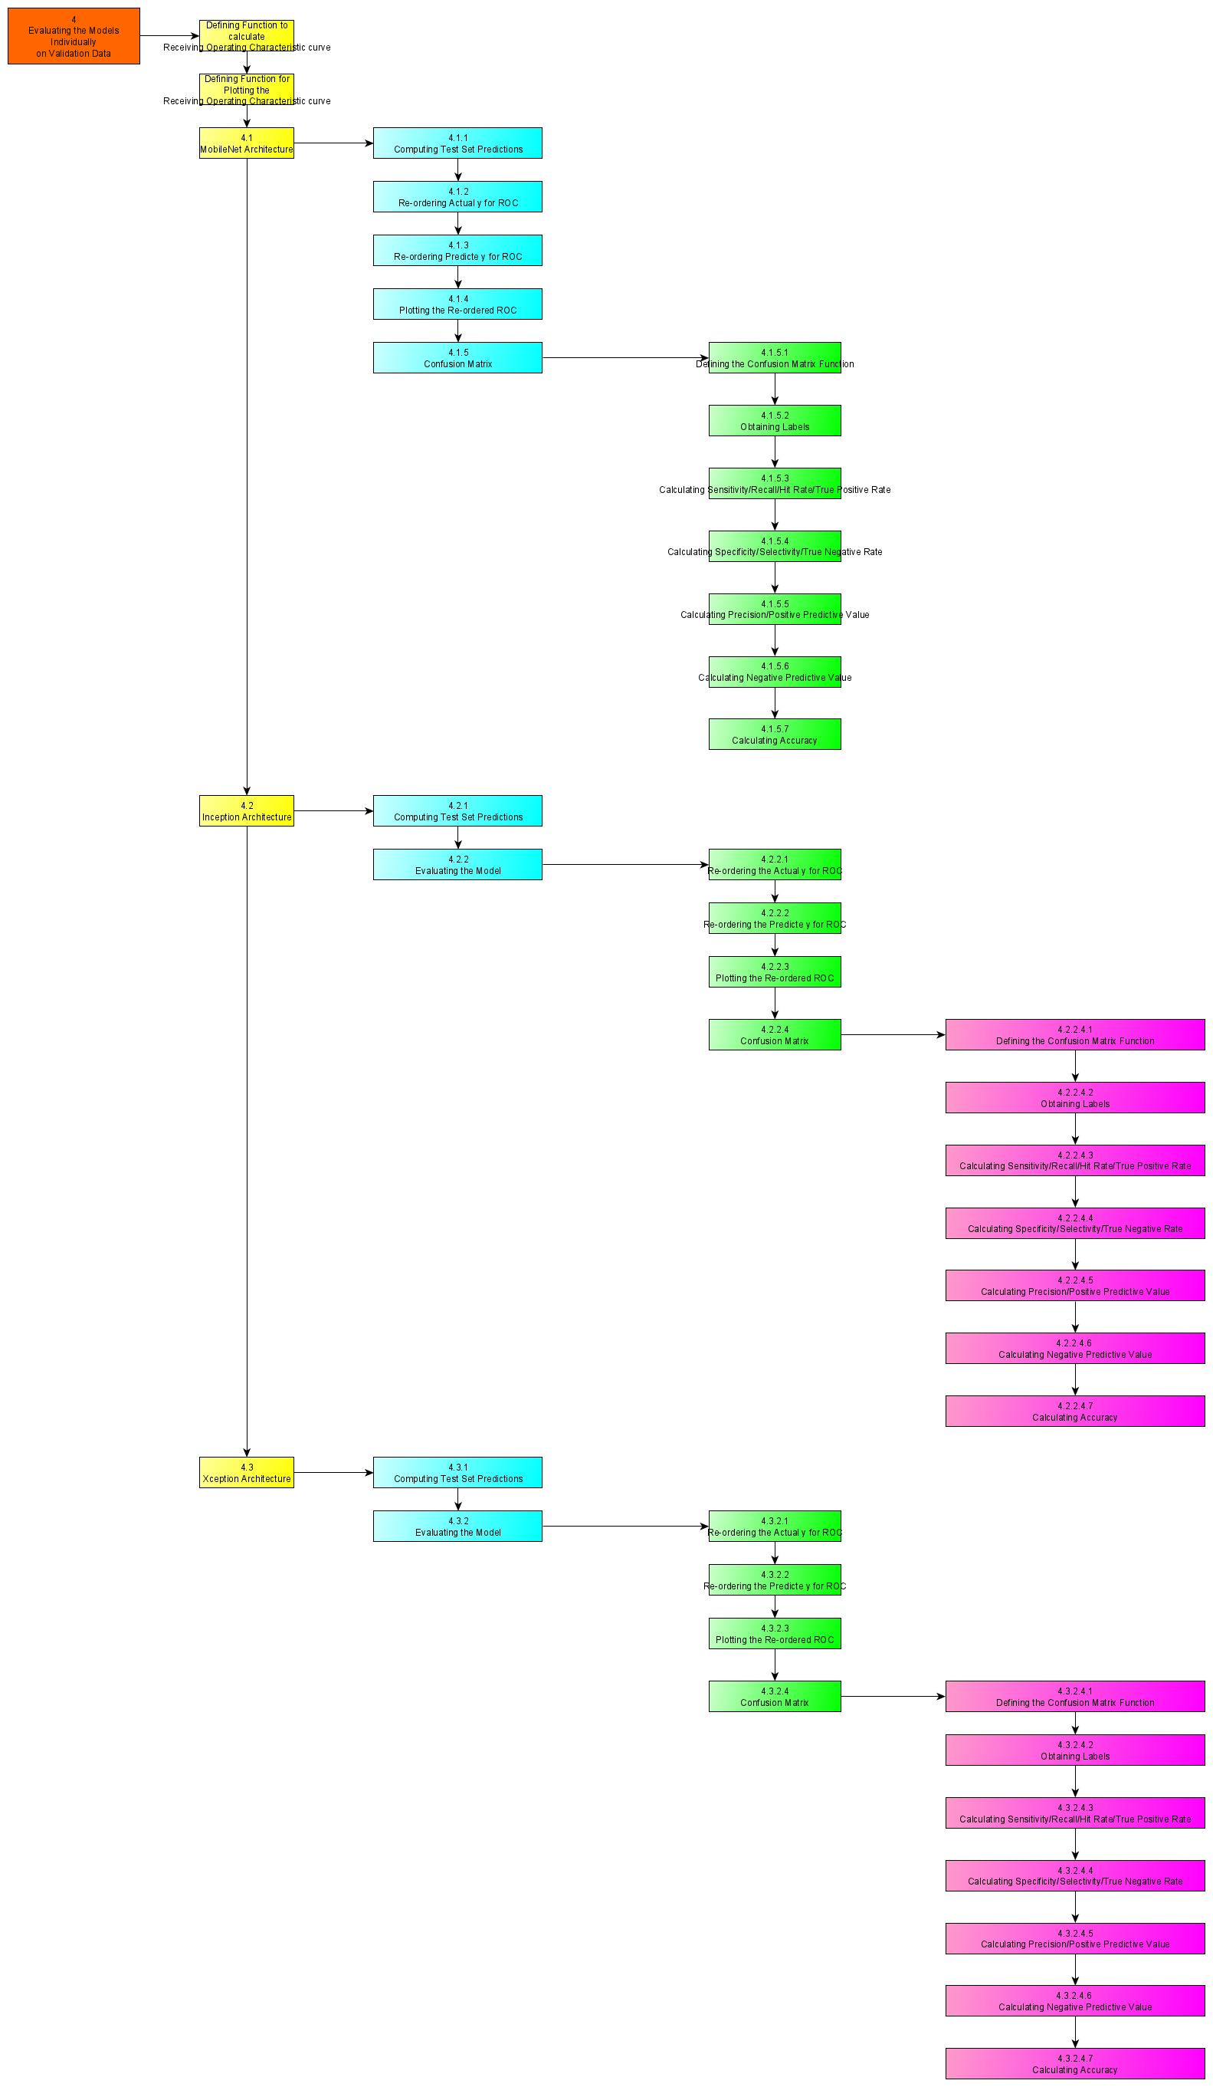

Figure 8: Proposed Architecture - Evaluating Models Individually on Validation Data (i)



Figure 9: Proposed Architecture - Evaluating the Models Individually on Validation Data (ii)

For the evaluation of the models on the Validation Data, we have used the Receiving Operating Characteristic Curve. A receiver operating characteristic curve, or ROC curve, is a graphical plot that illustrates the diagnostic ability of a binary classifier system as its discrimination threshold is varied. The method was originally developed for operators of military radar receivers starting in 1941, which led to its name.

For this, the we will be computing the test set predictions and then the model will be evaluated based on the Receiving Operating Characteristic Curve whose values will be obtained using the Confusion Matrix. Then, we will plot the values obtained for this in order to obtain the graph and check for the best possible values which can be used for prediction.

Further, after obtaining all these values, we will be calculating the Precision, Recall, Specificity, Sensitivity, Negative Predictive Value and Accuracy for further evaluation and after this, we can check the parameters, and if possible, we can tune the parameters to obtain better results.

At the end, we can compare the test results for the pre-trained architecture, as we have noted that the loss had reduced to the most efficient values possible and if we will train the model further with more epochs on the architectures, then we might make the model overfit on the data which can decrease the results and might lead to a higher number of wrong predictions, furthermore reducing the accuracy of the model and its efficiency.

## Evaluating the Models Together on Validation Data – Ensembling the Models

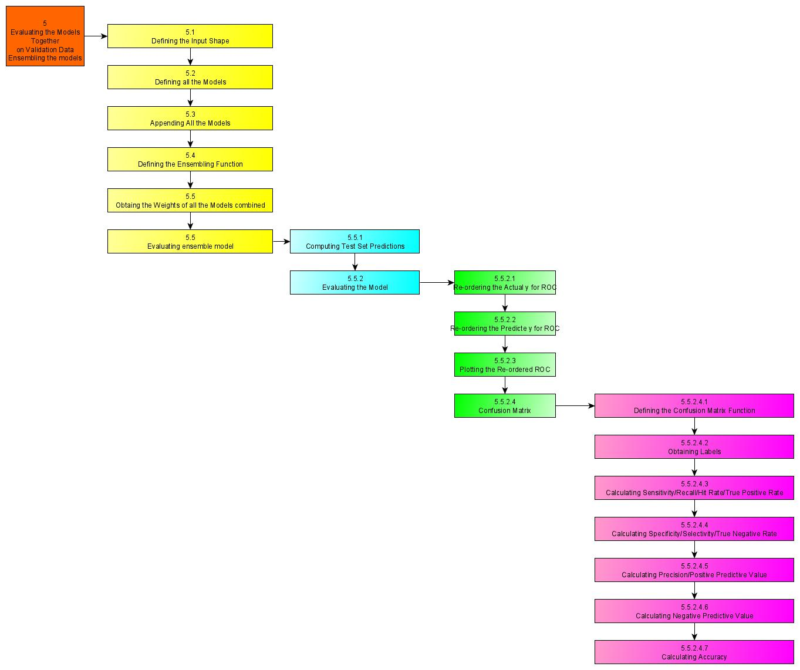

Figure 10: Proposed Architecture - Evaluating the Models Together on Validation Data

Defining a specific input shape for all the input images. The models will be brought together and appended so that the image passes through all the models one-by-one. The ensemble model will be defined which will contain all the models and the then the weights of the model will be combined and a file will be generated so that the weights are together into one and then they can be used together for the for the complete architecture.

For evaluating the models, we will be using the test set predictions and the ROC curve will be used whose computational values will be obtained using the Confusion Matrix. The other evaluation metrics are Precision, Recall, Sensitivity, Specificity, Negative Predictive Value and Accuracy. The results obtained for the Ensemble Model are better than each architecture individually.

## Evaluating the Models Individually on Testing Data

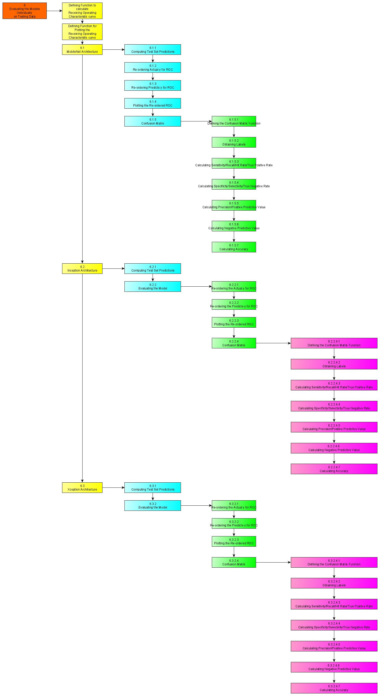

Figure 11: Proposed Architecture - Evaluating the Models Individually on Testing Data (i)



Figure 12: Proposed Architecture - Evaluating the Models Individually on Testing Data (ii)

For the evaluation of the models on the Testing Data, we have used the Receiving Operating Characteristic Curve. A receiver operating characteristic curve, or ROC curve, is a graphical plot that illustrates the diagnostic ability of a binary classifier system as its discrimination threshold is varied. The method was originally developed for operators of military radar receivers starting in 1941, which led to its name.

For this, the we will be computing the test set predictions and then the model will be evaluated based on the Receiving Operating Characteristic Curve whose values will be obtained using the Confusion Matrix. Then, we will plot the values obtained for this in order to obtain the graph and check for the best possible values which can be used for prediction.

Further, after obtaining all these values, we will be calculating the Precision, Recall, Specificity, Sensitivity, Negative Predictive Value and Accuracy for further evaluation and after this, we can check the parameters, and if possible, we can tune the parameters to obtain better results.

At the end, we can compare the test results for the pre-trained architecture, as we have noted that the loss had reduced to the most efficient values possible and if we will train the model further with more epochs on the architectures, then we might make the model overfit on the data which can decrease the results and might lead to a higher number of wrong predictions, furthermore reducing the accuracy of the model and its efficiency.

The results obtained on the Testing data are very similar to the results obtained on the Validation data.

## Evaluating the Models Together on Testing Data – Ensembling the Models

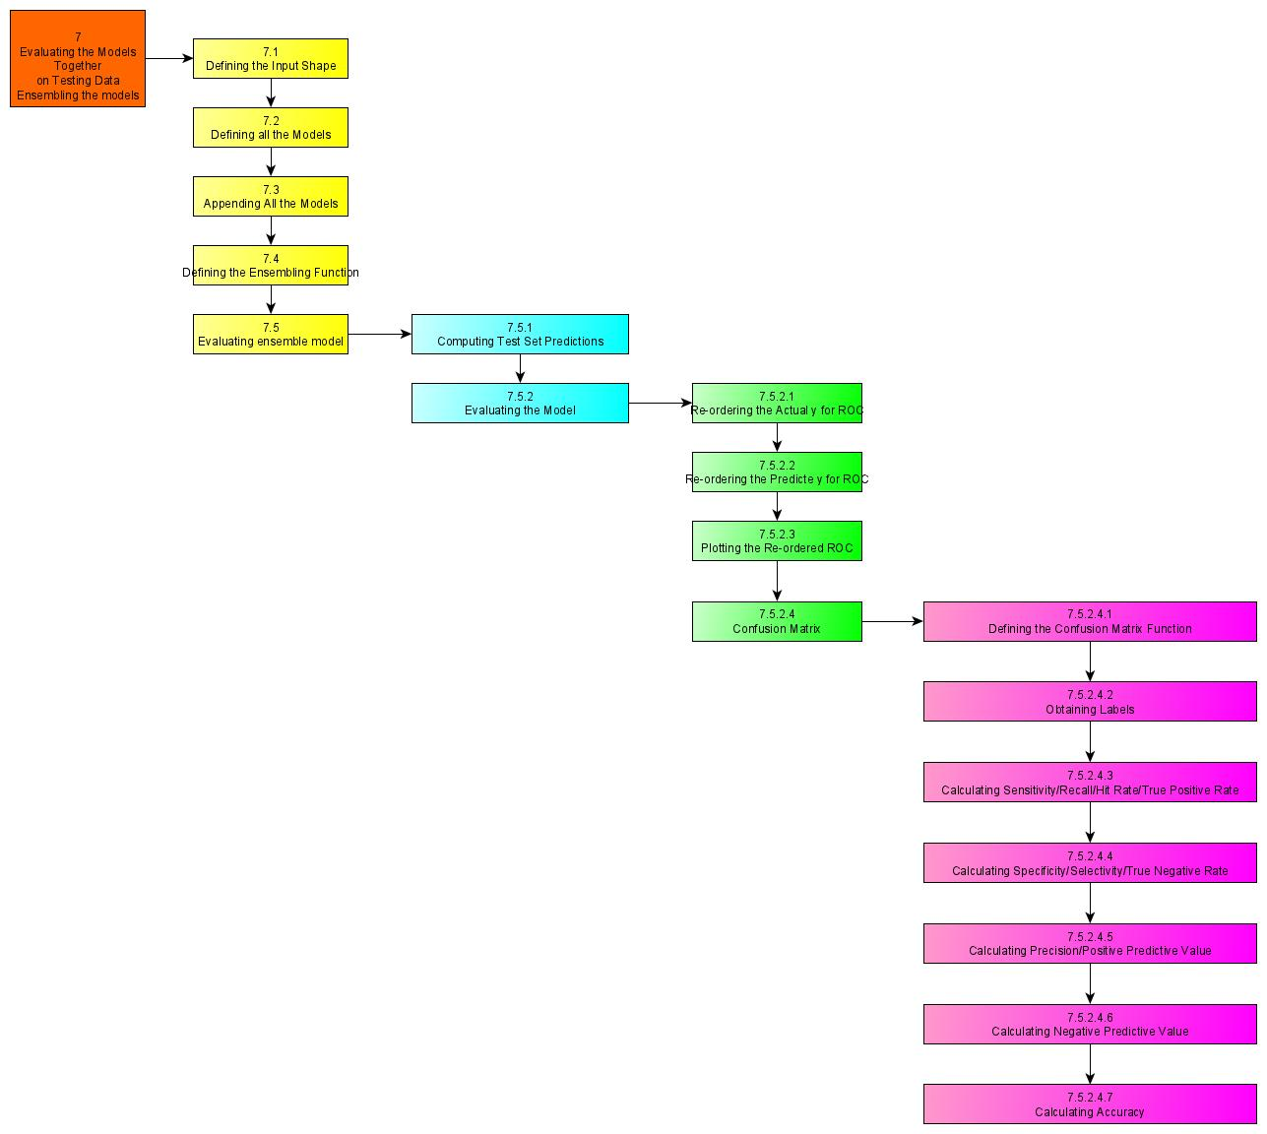

Figure 13: Proposed Model - Evaluating the Models Together on Testing Data

Defining a specific input shape for all the input images. The models will be brought together and appended so that the image passes through all the models one-by-one. The ensemble model will be defined which will contain all the models and the then the weights of the model will be combined and a file will be generated so that the weights are together into one and then they can be used together for the for the complete architecture.

For evaluating the models, we will be using the test set predictions and the ROC curve will be used whose computational values will be obtained using the Confusion Matrix. The other evaluation metrics are Precision, Recall, Sensitivity, Specificity, Negative Predictive Value and Accuracy. The results obtained for the Ensemble Model are better than each architecture individually.

## Localization

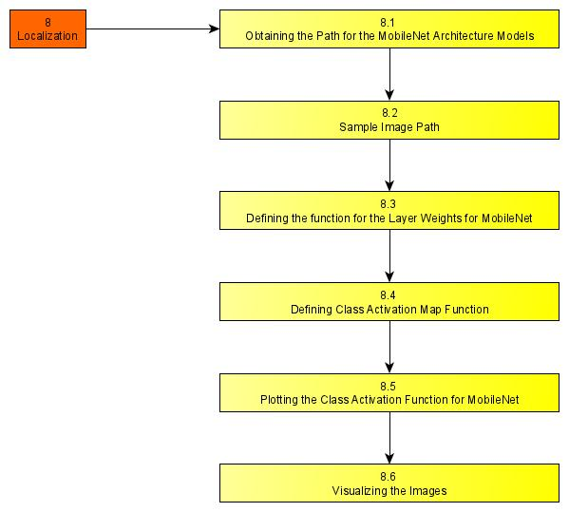

Figure 14: Proposed Architecture - Localization

For this, we define the Class Activation Map and then we create another function using which we can display the results obtained on a particular file, as we can use the address of the that image directly and then plot to even check the results obtained for the model which we have created. The results are displayed along with the plot which is created containing the Image and another heatmap image displayed along.

## Saving the Complete Model for the Python Interface Application

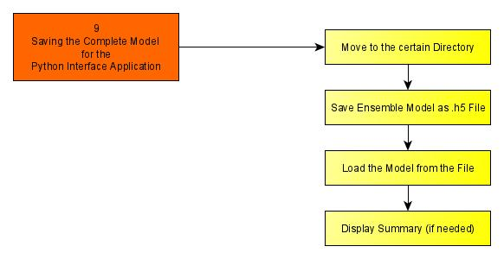

Figure 15: Proposed Architecture - Saving the Complete Model for the Application Interface

First, we will move to the required directory where we can save the file for the model. Then, we will use the complete model and use the save() function.

## Converting the .h5 File to .tflite File for the Python Interface APplication

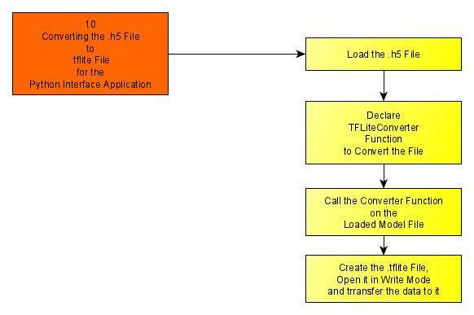

Figure 16: Converting the H5 File to TFLITE File for Application Interface

We will first load the saved model file and then we will use the converter function to convert the file into the into the required format which we can use for the Interface Application.

# Proposed Architecture Specifications

## Data Selection

The goal of the challenge is to help participants develop image analysis tools to enable the automated diagnosis of melanoma from dermoscopic images. Image analysis of skin lesions is composed of 3 parts:

* Part 1: Lesion Segmentation
* Part 2: Detection and Localization of Visual Dermoscopic Features/Patterns
* Part 3: Disease Classification

This challenge provides training data (150 images) and blind held-out test dataset (~600 images) will be provided for participants to generate and submit automated results.

## Backgraound

### Melanoma

Skin cancer is a major public health problem, with over 5 million newly diagnosed cases in the United States each year. Melanoma is the deadliest form of skin cancer, responsible for over 9,000 deaths each year.

### Dermoscopy

As pigmented lesions occurring on the surface of the skin, melanoma is amenable to early detection by expert visual inspection. It is also amenable to automated detection with image analysis. Given the widespread availability of high-resolution cameras, algorithms that can improve our ability to screen and detect troublesome lesions can be of great value. As a result, many centres have begun their own research efforts on automated analysis. However, a centralized, coordinated, and comparative effort across institutions has yet to be implemented.

Dermoscopy is an imaging technique that eliminates the surface reflection of skin. By removing surface reflection, visualization of deeper levels of skin is enhanced. Prior research has shown that when used by expert dermatologists, dermoscopy provides improved diagnostic accuracy, in comparison to standard photography. As inexpensive consumer dermatoscope attachments for smart phones are beginning to reach the market, the opportunity for automated dermoscopic assessment algorithms to positively influence patient care increases.



Figure 17: Sample Images of the Dataset

## Exploratory Data Analysis

### Checking the Types of Data

There are four types of EDA in all:

* **Univariate non-graphical**: This is the simplest form of data analysis among the four options. In this type of analysis, the data that is being analyzed consists of just a single variable. The main purpose of this analysis is to describe the data and to find patterns.
* **Univariate graphical**: Unlike the non-graphical method, the [graphical](https://analyticsindiamag.com/whoever-said-machine-learning-is-all-about-statistics-is-wrong/) method provides the full picture of the data. The three main methods of analysis under this type are histogram, stem and leaf plot, and box plots. The histogram represents the total count of cases for a range of values. Along with the data values, the stem and leaf plot show the shape of the distribution. The box plots graphically depict a summary of minimum, first quartile median, third quartile, and maximum.
* **Multivariate non-graphical**: The multivariate non-graphical type of EDA generally depicts the relationship between multiple variables of data through cross-tabulation or statistics.
* **Multivariate graphical**: This type of [EDA](https://analyticsindiamag.com/hands-on-guide-to-datatable-library-for-faster-eda/) displays the relationship between two or more set of data. A bar chart, where each group represents a level of one of the variables and each bar within the group represents levels of other variables.

### Finding the Outliers

There exist three different options on how to treat non-error outliers:

1. Keep
2. Delete
3. Recode

#### Keep

When most of the detected outliers are non-error outliers and rightfully belong to the population of interest.

#### Delete

The most straightforward option is to delete any outlying observation. However, this strategy bears a high risk of losing information. Especially if you find many outlying data points, try to avoid this. Also, deleting interesting and influential outliers (points that belong to the population of interest) can falsely impact any output, e.g., prediction or test result, you aim to achieve.

#### Recode

Recoding outliers is a good option to treat outliers and keep as much information as possible simultaneously. This option should always be accompanied by sound reasoning and explanation.

### Data Visualization

* Univariate data analysis
* Bivariate data analysis
* Line plot
* Box plot
* Scatter matrix

## Data Pre-Processing

### Splitting the Data

Divide the dataset into three parts to avoid overfitting or underfitting and model selection bias called -

1. Training set (Has to be the largest set)
2. Cross-Validation set or Development set or Dev set
3. Testing Set

#### Underfitting:

Underfitting mainly occurs when a machine learning algorithm is not able to capture the lower trend of data which is mainly when data is nor well fitted inside the model.

#### overfitting?

When machine learning algorithm is trained on very well data and very closely on a dataset which can lead to a negative impact on the performance of the system leading to the wrong system and prediction model.

### Checking for Missing Values

There are three categories of missing data:

* **MCAR** (Missing Completely At Random) where the pattern of missingness is statistically independent of the data record. Example: you have a data set on a piece of paper and you spill coffee on the paper destroying part of the data.
* **MAR** (Missing At Random) where the probability distribution of the pattern of missingness is functionally dependent upon the observable component in the record. MCAR is a special case of MAR. Example: if a child does not attend an educational assessment because the child is (genuinely) ill, this might be predictable from other data we have about the child’s health, but it would not be related to what we would have measured had the child not been ill.
* **MNAR** (Missing Not at Random) which is defined as the case which is NOT MAR, or when the missingness is specifically related to what is missing. Example: a person does not attend a drug test because the person took drugs the night before.

### Checking Categorical Features

Two major types of categorical features are

* **Nominal** – These are variables which are not related to each other in any order such as colour (black, blue, green).
* **Ordinal** – These are variables where a certain order can be found between them such as student grades (A, B, C, D, Fail).

### Normalizing Dataset

The goal of normalization is to change values to a common scale without distorting the difference between the range of values.

Using this technique, we are going to have a mean of 0 and a standard deviation of 1 in our dataset. We can either do it normally by combining different functions in numpy, i.e.,

z = $\frac{x.values-np.mean(x.values)}{np.std(x.values)}$

where *x* is a data frame with all numerical indices. If we want to retain the values in a data frame, then we can simply remove. values in front of it.

## Feature Transformation

### Why do we need Feature Transformation and Scaling?

Oftentimes, we have datasets in which different columns have different units – like one column can be in kilograms, while another column can be in centimetres. Furthermore, we can have columns like income which can range from 20,000 to 100,000, and even more; while a benign column which can range from 0 to 100(at the most). Thus, Malignant is about 1,000 times larger than age. When we feed these features to the model as is, there is every chance that the Malignant values will influence the result more due to its larger value. But this doesn’t necessarily mean it is more important as a predictor. So, to give importance to both Benign, and Malignant, we need feature scaling.

### Feature Transformations used in the Models

## Model Selection

Tensors often offer more natural representations of data, e.g., consider video, which consists of obviously correlated images over time. You *can* turn this into a matrix, but it's just not natural or intuitive (what does a factorization of some matrix-representation of video mean?).

Tensors are trending for several reasons:

* our understanding of multilinear algebra is improving rapidly, specifically in various types of factorizations, which in turn helps us to identify new potential applications (e.g., [multiway component analysis](http://arxiv.org/pdf/1403.4462.pdf))
* software tools are emerging (e.g., [Tensorlab](http://tensorlab.net/)) and are [being welcomed](http://radar.oreilly.com/2015/03/lets-build-open-source-tensor-libraries-for-data-science.html)
* Big Data applications can often be solved using tensors, for example [recommender systems](http://xavier.amatriain.net/pubs/karatzoglu-recsys-2010.pdf), and Big Data itself is hot
* increases in computational power, as some tensor operations can be hefty (this is also one of the major reasons why deep learning is so popular now)

## Model Training

Most machines cannot learn until and unless they have a proper dataset or at least any kind of **data**. And modern data is often multi-dimensional (having more than one dimensions). Tensors can play an important role in Machine Learning/Deep Learning by encoding multi-dimensional data. For example (a simple example to explain the advantages of using them), a picture is generally represented by three fields: *width, height*and *depth (color)*. It makes total sense to encode it as a 3D tensor. However, more than often we are dealing with tens of thousands of pictures. Hence this is where the fourth field, *sample size* comes into play. A series of images, such as the famous MNIST dataset, can be easily stored in a 4D tensor in [Tensorflow](https://hackernoon.com/learning-ai-if-you-suck-at-math-p4-tensors-illustrated-with-cats-27f0002c9b32). This representation allows problems involving big data to be solved easily.

(ML Concepts: Tensors, 2018)

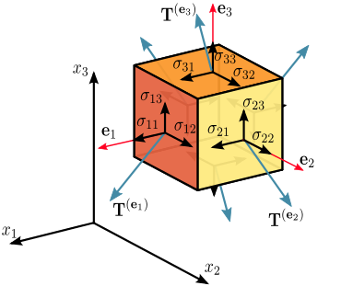

Figure 18: Visualizing a Tensor

A real-life example would be in most recommender systems, model-based Collaborative Filtering approaches such as Matrix Factorization do not the flexibility of integrating context information into the models. By using a **N-dimensional tensor** instead of the traditional 2D User-Item matrix, researchers have developed a more robust [model](https://xamat.github.io/pubs/karatzoglu-recsys-2010.pdf) that provides context-aware recommendations. Increase in computing power in the recent years also allows these heavy tensor operations to be realized.

At this point you may wonder: why do most machine learning algorithms rely on vectors and matrices, while deep learning algorithms and neural networks mostly rely on tensors? A simple answer is that deep learning usually involves hundreds, if not thousands, of dimensions and fields. As we discussed previously, this is best represented by tensors since they can represent anything ranging from *zero* to *N* dimensions. In computer vision problems such as the [Merck Molecular Activity Challenge](https://www.kaggle.com/c/MerckActivity), images can easily be broken down into a few hundred features. Therefore, tensors can be best viewed as containers that wrap and store data features in the context of machine learning and deep learning.

# Project Demonstration

## Application Interface

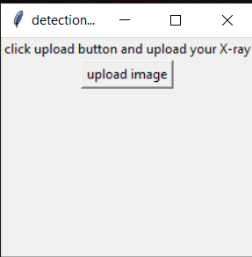

Figure 19: First View of Interface

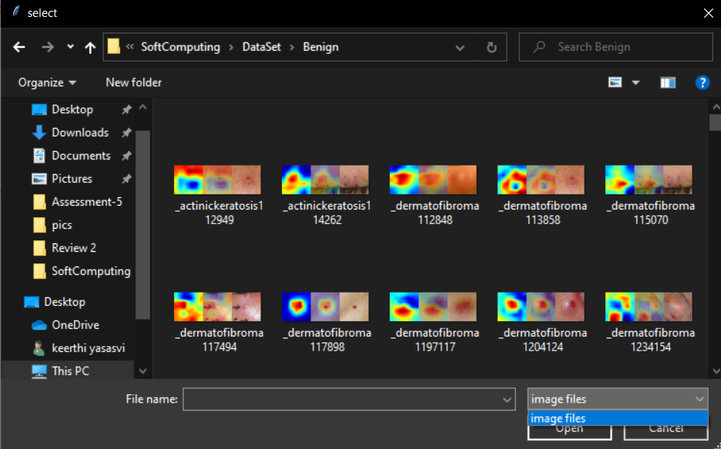

Figure 20: Selecting a File for Uploading

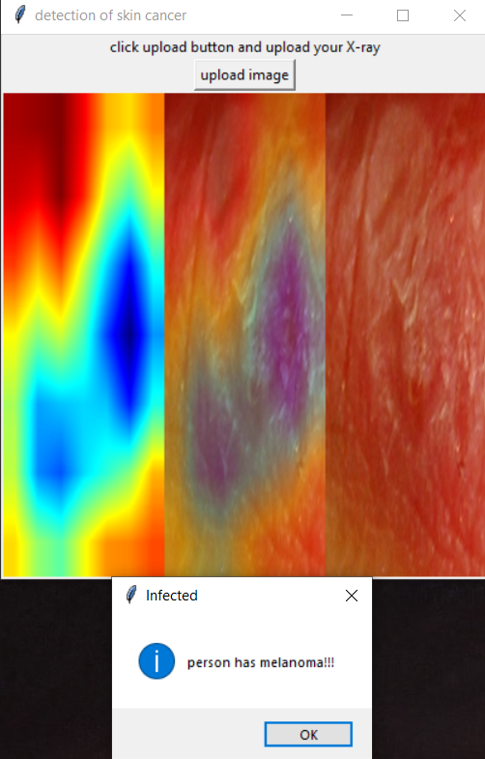

Figure 21: Display of Output

## Mounting Google Drive

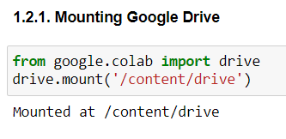

Figure 22: Project Demonstration - Mounting Google Drive for Authorization

## Loading and Display the CSV Dataset

### Training CSV File

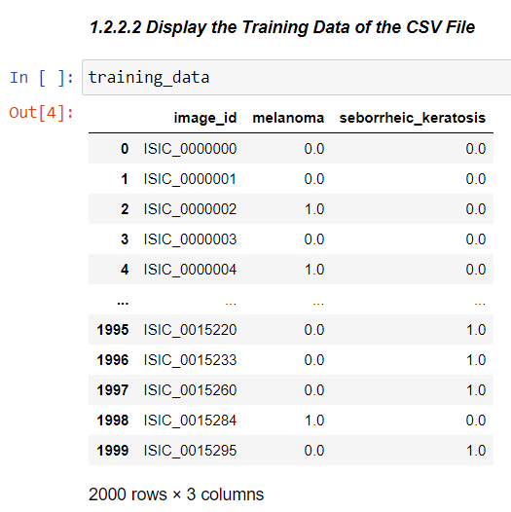

Figure 23: Project Demonstration - Data in CSV File for Training Data

### Validation CSV File

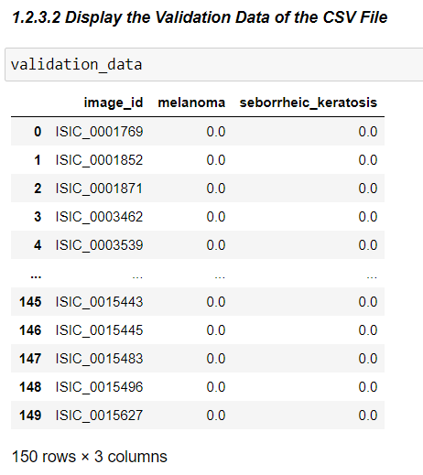

Figure 24: Project Demonstration - Data in CSV File for Validation Data

### Testing CSV File

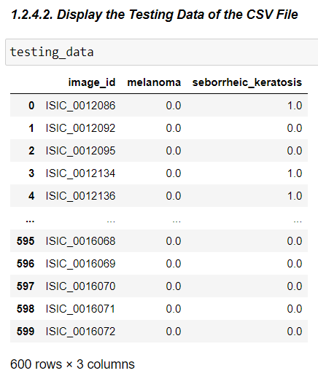

Figure 25: Project Demonstration - Data in CSV File for Testing Data

## Converting the Data into Tensors

### Training Tensor

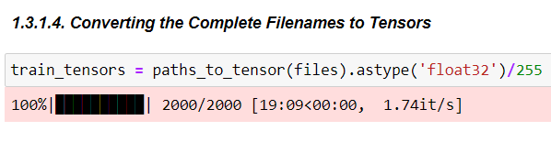

Figure 26: Project Demonstration - Converting Training Files to Tensors

### Validation Tensor

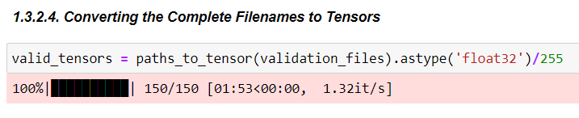

Figure 27: Project Demonstration - Converting Validation Files to Tensors

### Testing Tensor

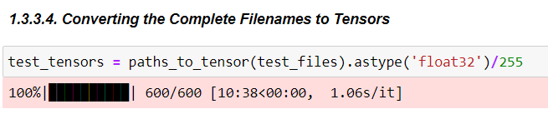

Figure 28: Project Demonstration - Converting Testing Files to Tensors

## Fitting into the Models

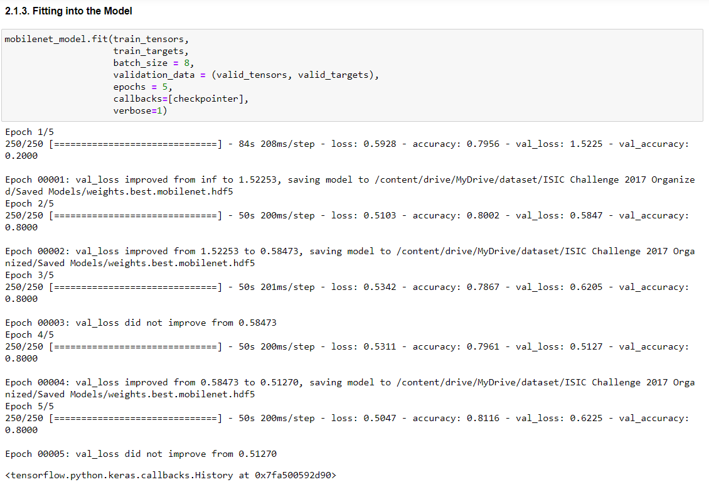

Figure 29: Project Demonstration - Training the MobileNet Architecture

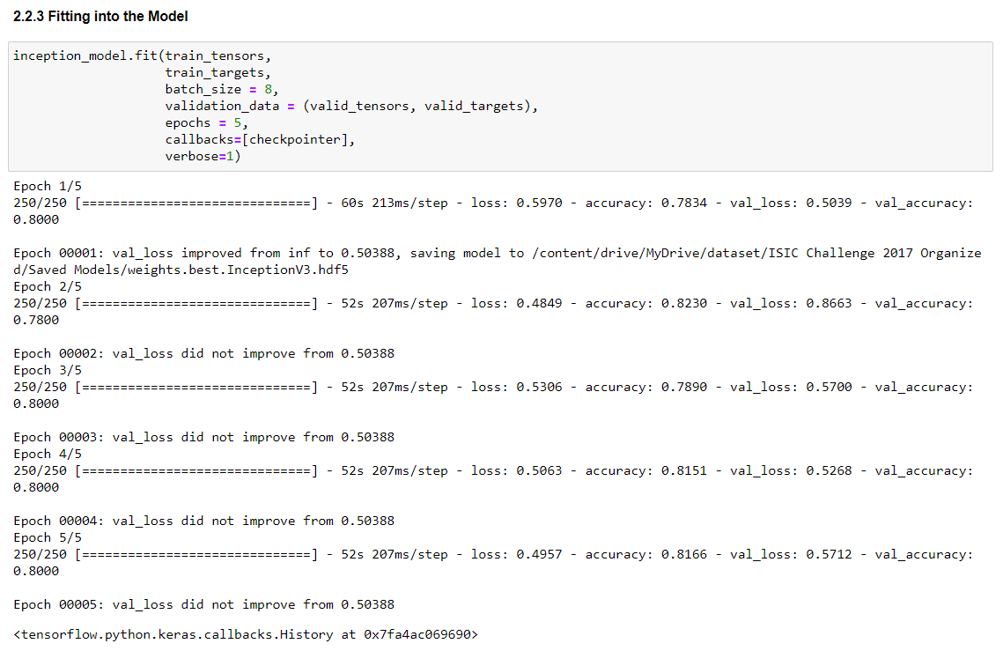

Figure 30: Project Demonstration - Training the Inception Architecture

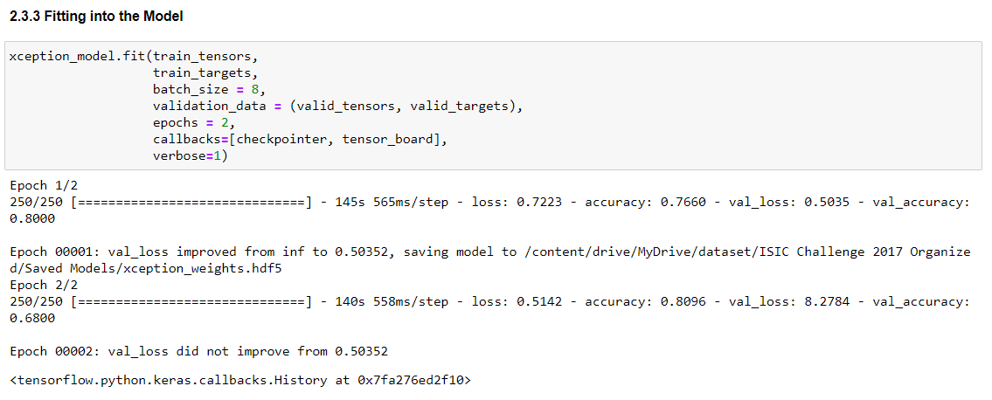

Figure 31: Project Demonstration - Training the Xception Architecture

## Predictions on a Sample Image

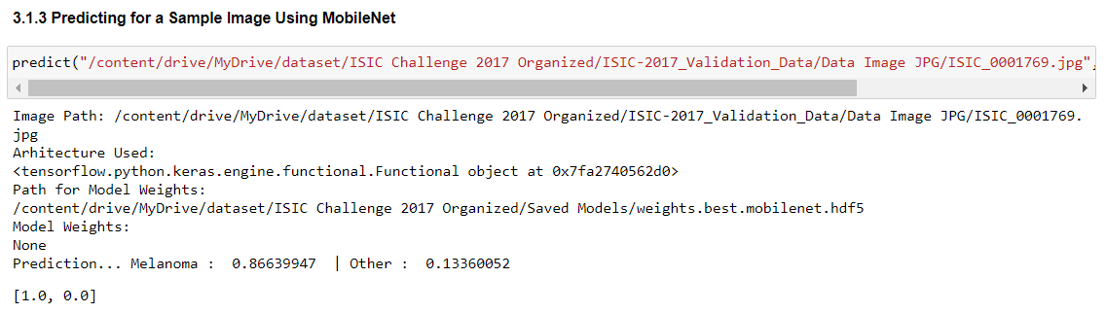

Figure 32: Project Demonstration - Predicting on a Sample Image using MobileNet

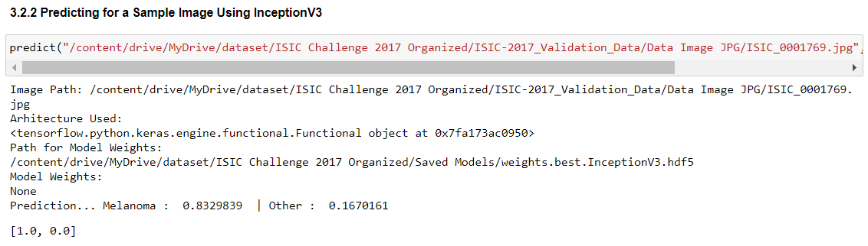

Figure 33: Project Demonstration - Predicting on a Sample Image using Inception

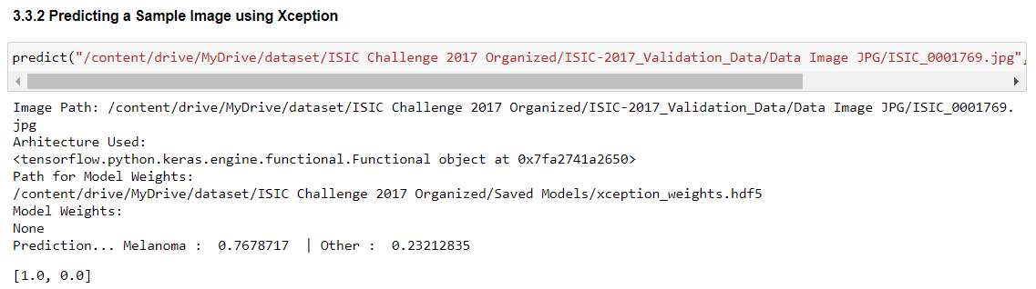

Figure 34: Project Demonstration - Predicting on a Sample Image using Xception

## Evaluation of MobileNet on Validation Data

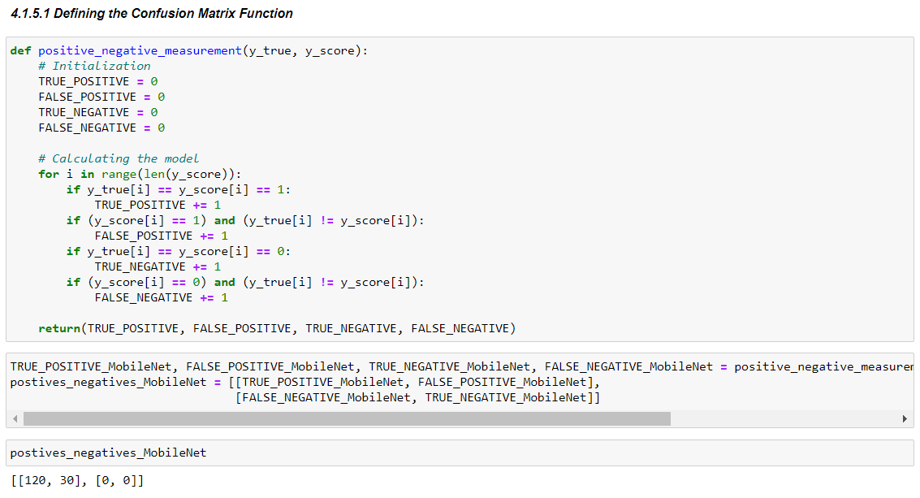

Figure 35: Project Demonstration - Evaluation of MobileNet on Training Data - Confusion Matrix

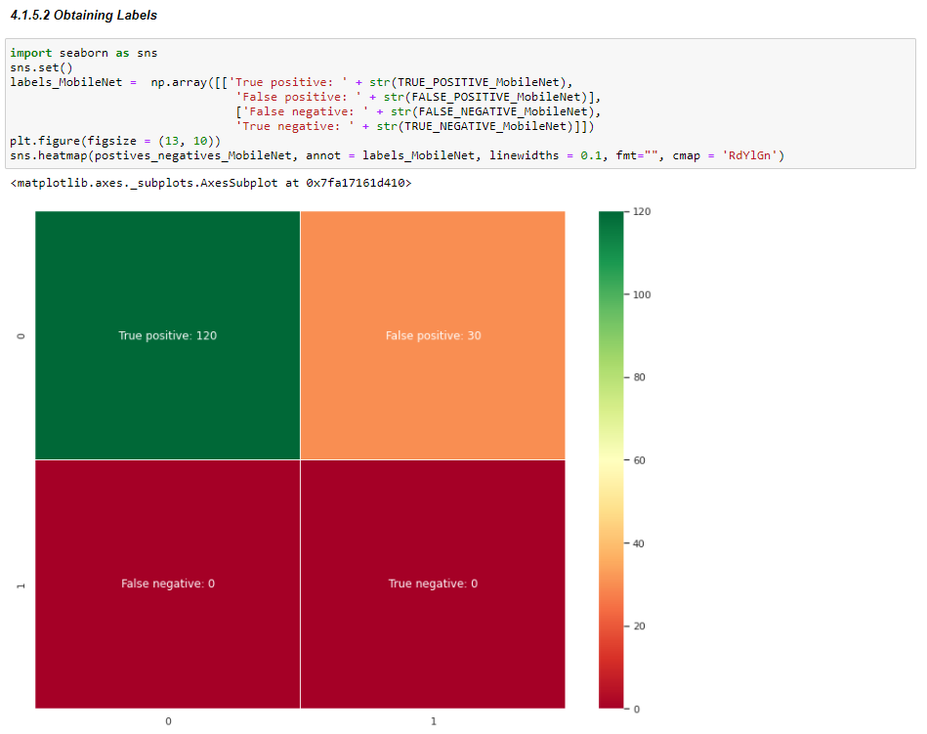

Figure 36: Project Demonstration - Evaluation of MobileNet on Training Data - Obtaining Labels

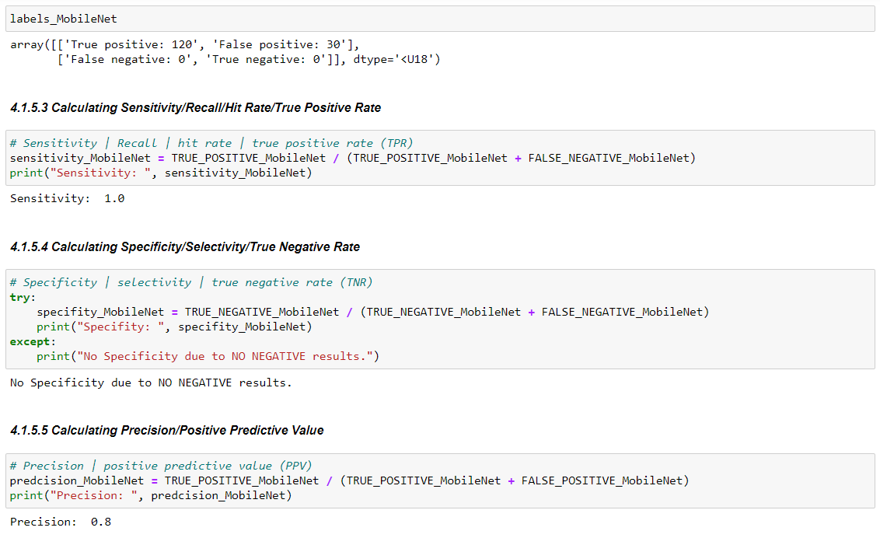

Figure 37: Project Demonstration - Evaluation of MobileNet on Training Data(i)

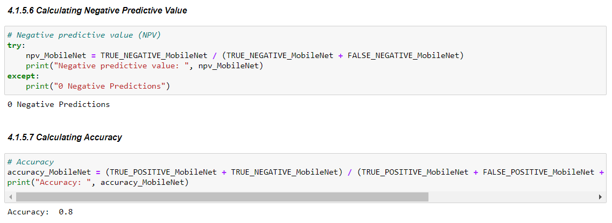

Figure 38: Project Demonstration - Evaluation of MobileNet on Training Data(ii)

## Evaluation of Inception on Validation Data

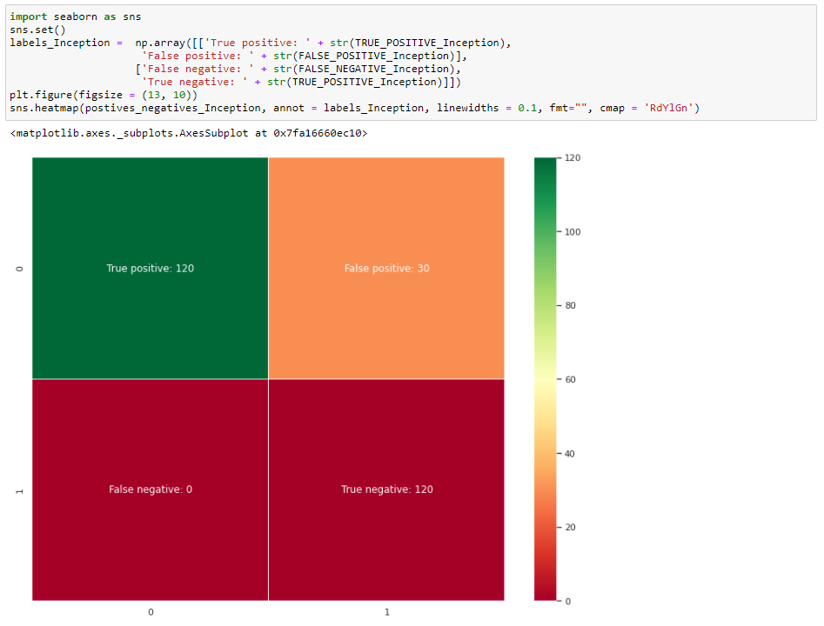

Figure 39: Project Demonstration - Evaluation of Inception on Training Data - Confusion Matrix

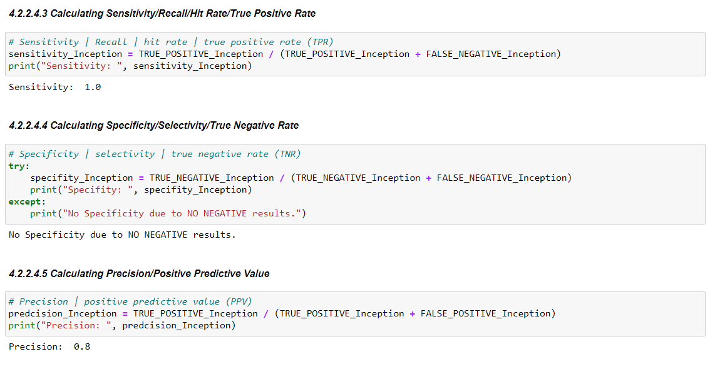

Figure 40: Project Demonstration - Evaluation of Inception on Training Data(i)

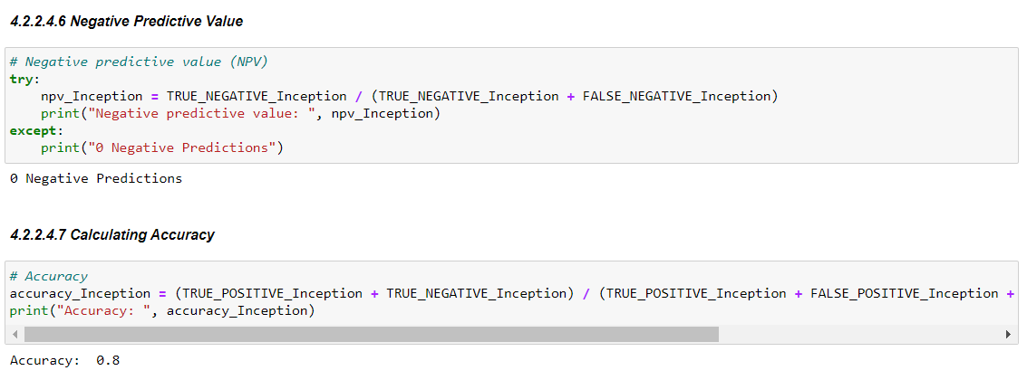

Figure 41: Project Demonstration - Evaluation of Inception on Training Data(ii)

## Evaluation of Xception on Validation Data

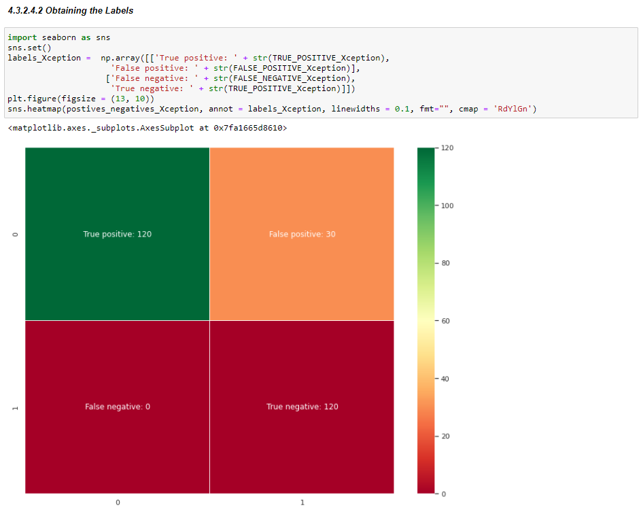

Figure 42: Project Demonstration - Evaluation of Xception on Training Data - Confusion Matrix

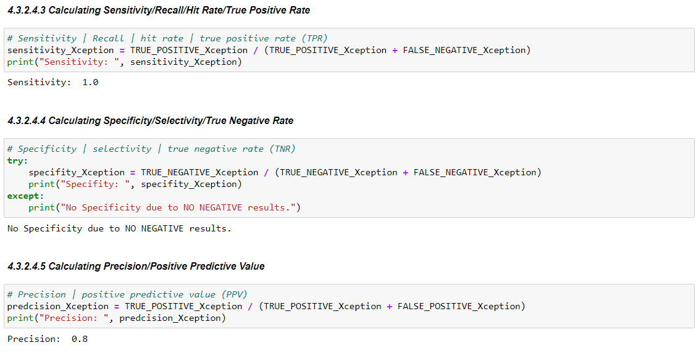

Figure 43: Project Demonstration - Evaluation of Xception on Training Data(i)

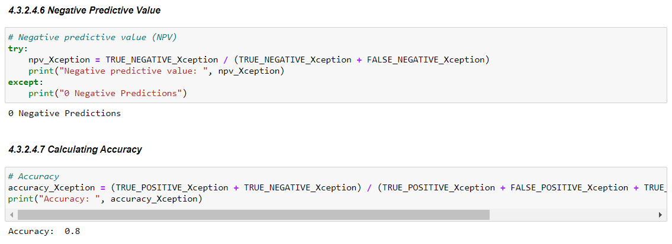

Figure 44: Project Demonstration - Evaluation of Xception on Training Data (ii)

## Evaluation of Models Together on Validation Data

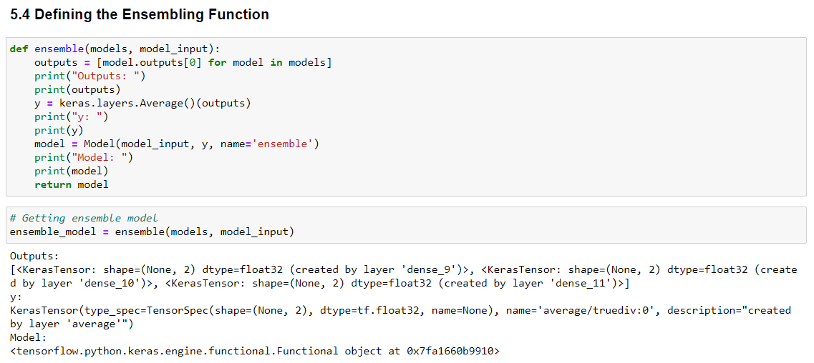

Figure 45: Project Demonstration - Evaluation of Models Together on Validation Data - Defining Ensemble Function

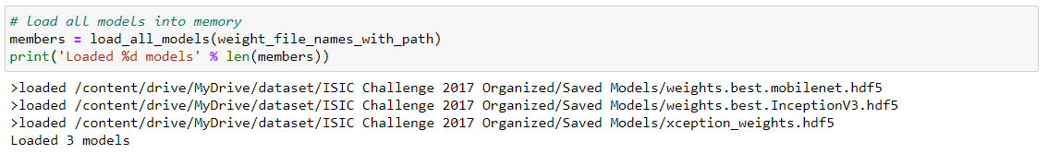

Figure 46: Project Demonstration - Evaluation of Models Together on Validation Data - Loading all Model Weights

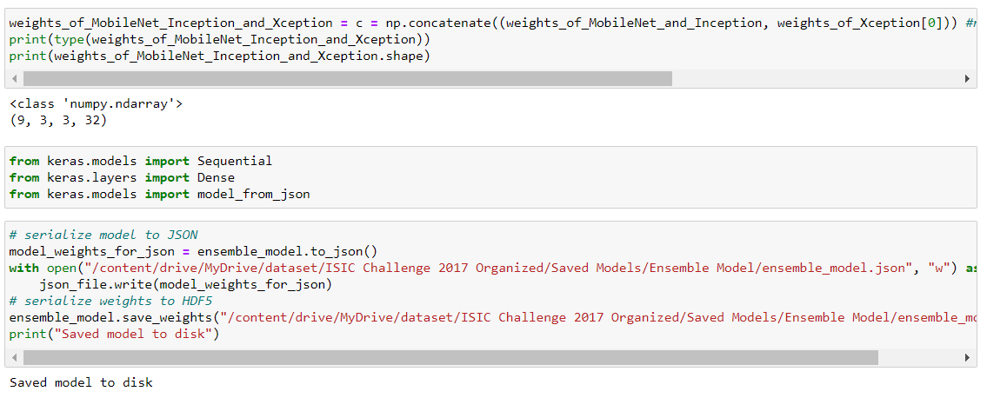

Figure 47: Project Demonstration - Evaluation of Models Together on Validation Data - Serializing Weights into one

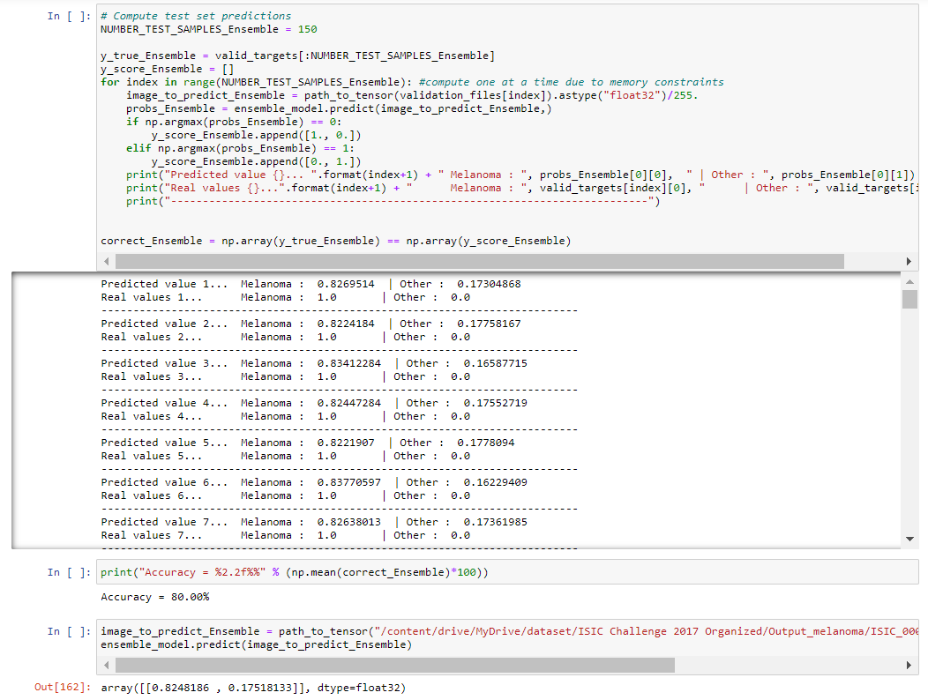

Figure 48: Project Demonstration - Evaluation of Models Together on Validation Data - Computing Test Set Predictions

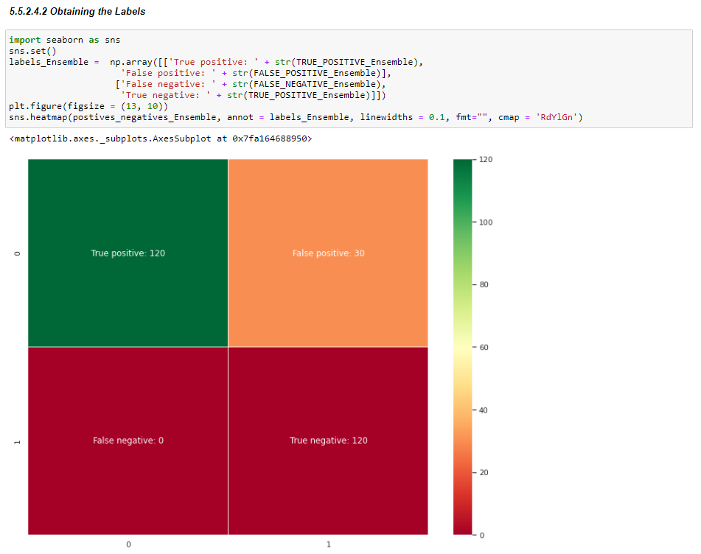

Figure 49: Project Demonstration - Evaluation of Models Together on Validation Data - Obtaining Labels

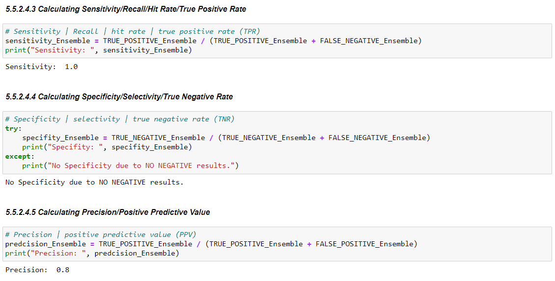

Figure 50: Project Demonstration - Evaluation of Models Together on Validation Data(i)

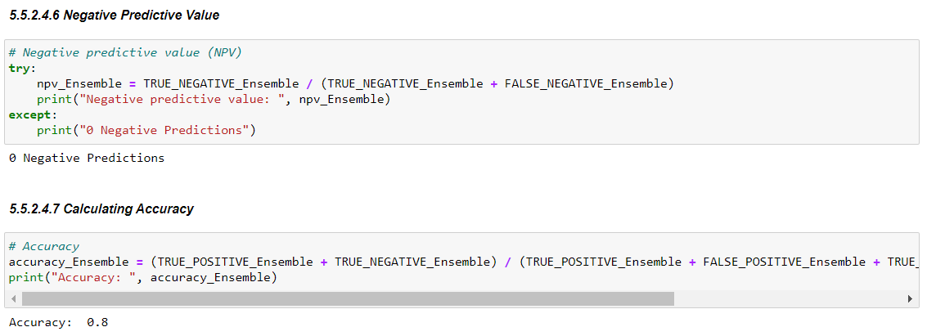

Figure 51: Project Demonstration - Evaluation of Models Together on Validation Data(ii)

## Evaluating the Models Individually on Testing Data

### MobileNet

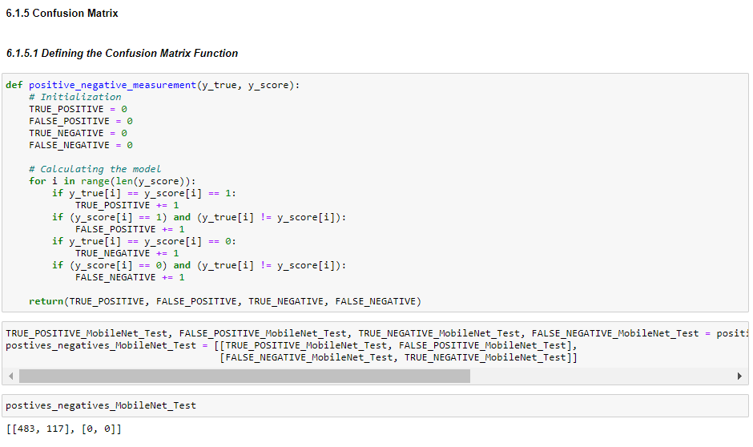

Figure 52: Project Demonstration - Evaluation of MobileNet Model Individually on Testing Data - Confusion Matrix

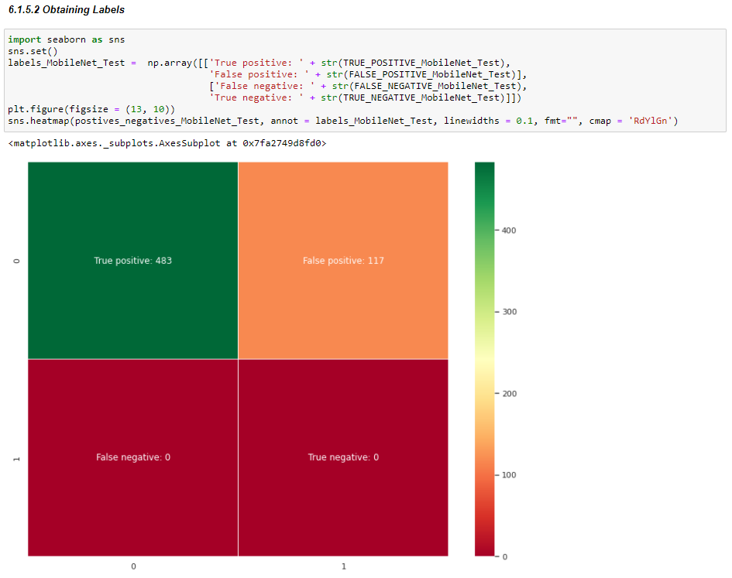

Figure 53: Project Demonstration - Evaluation of MobileNet Model Individually on Testing Data - Obtaining Labels

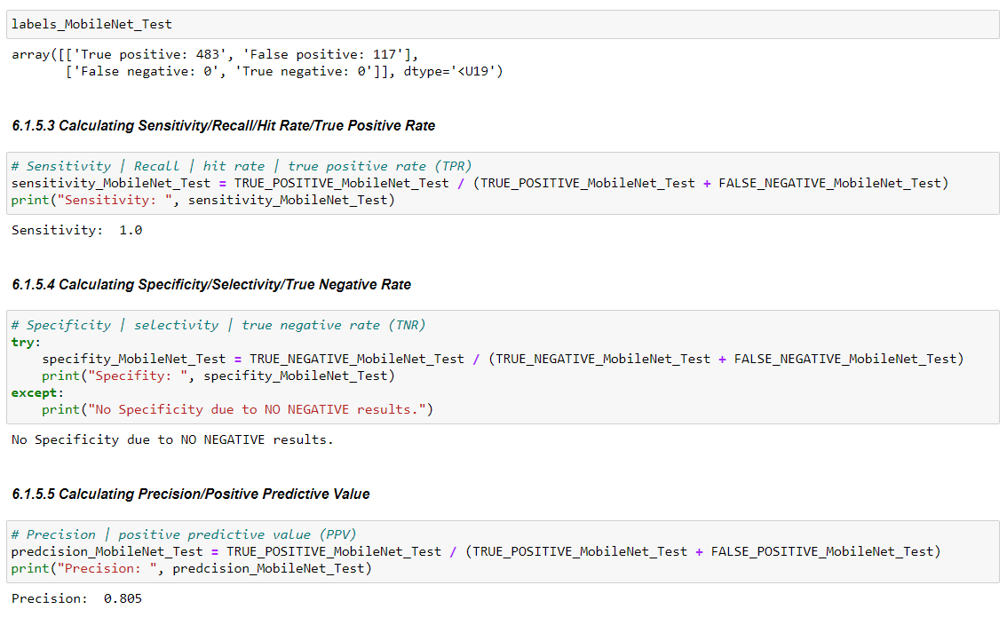

Figure 54: Project Demonstration - Evaluation of MobileNet Model Individually on Testing Data(i)

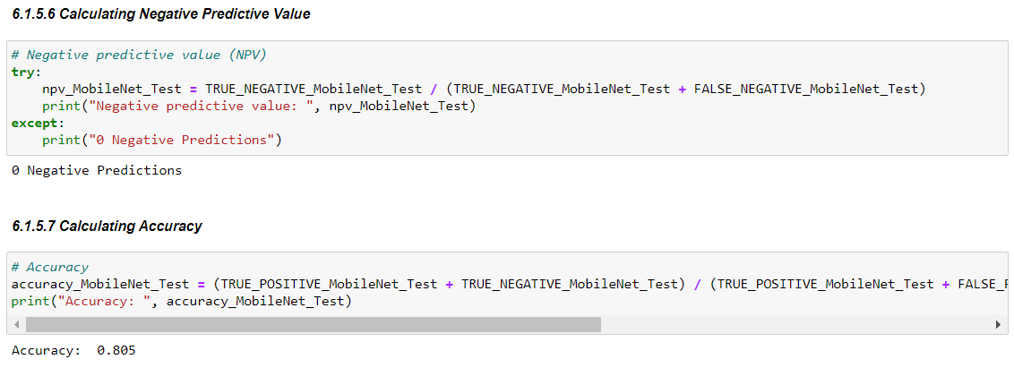

Figure 55: Project Demonstration - Evaluation of MobileNet Model Individually on Testing Data(ii)

### Inception

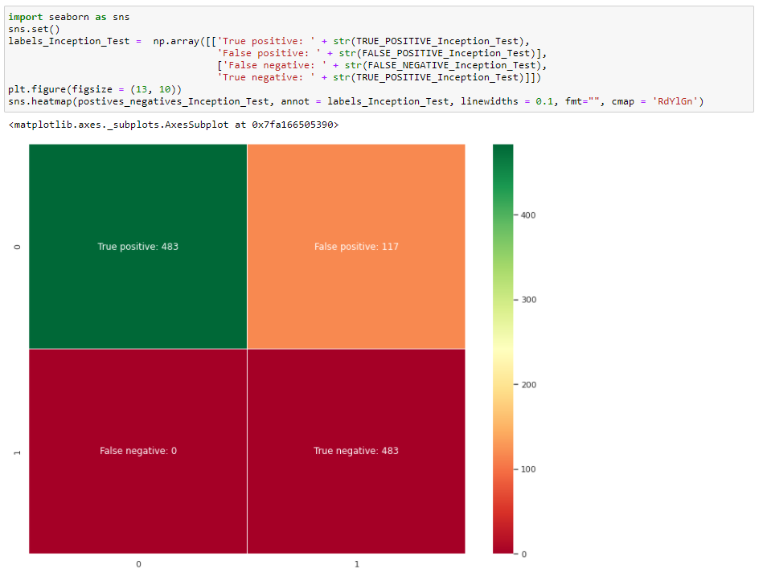

Figure 56: Project Demonstration - Evaluation of Inception Model Individually on Testing Data - Confusion Matrix

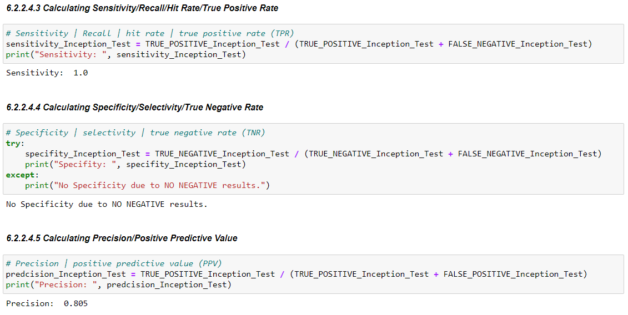

Figure 57: Project Demonstration - Evaluation of Inception Model Individually on Testing Data(i)

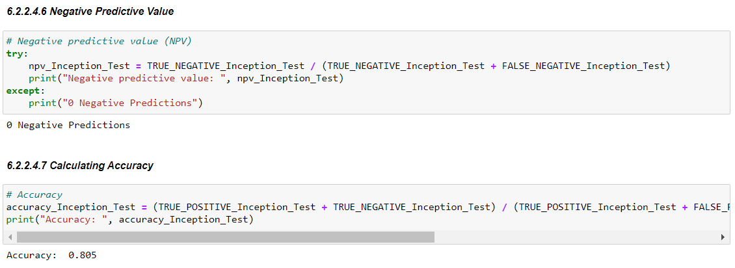

Figure 58: Project Demonstration - Evaluation of Inception Model Individually on Testing Data(ii)

### Xception

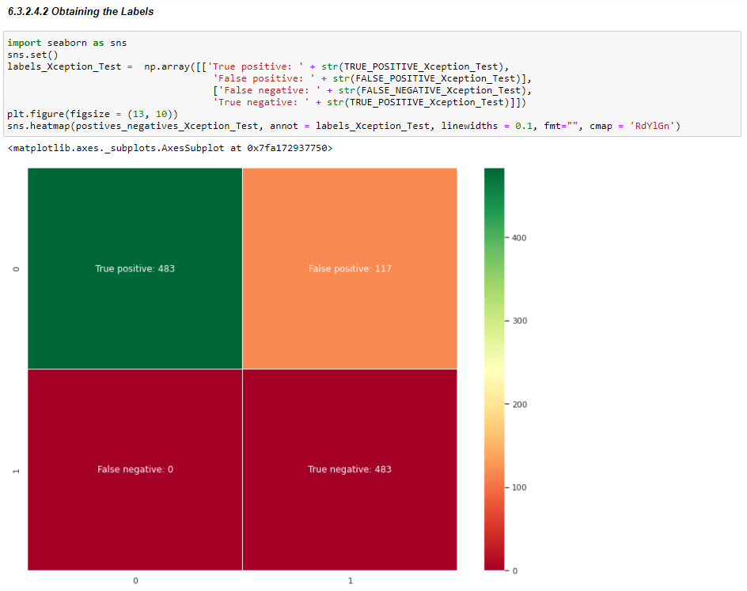

Figure 59: Project Demonstration - Evaluation of Xception Model Individually on Testing Data - Obtaining Labels

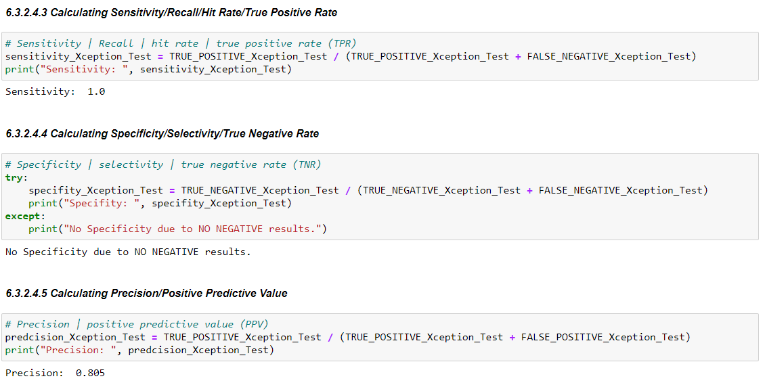

Figure 60: Project Demonstration - Evaluation of Xception Model Individually on Testing Data(i)

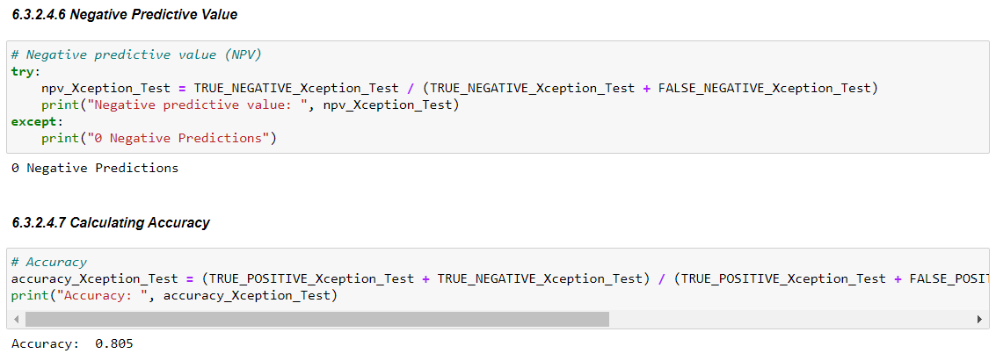

Figure 61: Project Demonstration - Evaluation of Xception Model Individually on Testing Data(ii)

## Evaluating the Models Together on Testing Data - Ensembling the models

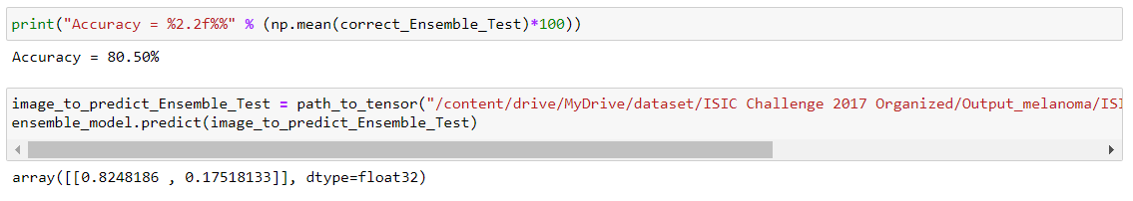

Figure 62: Project Demonstration - Evaluation of Models Together on a Sample Image

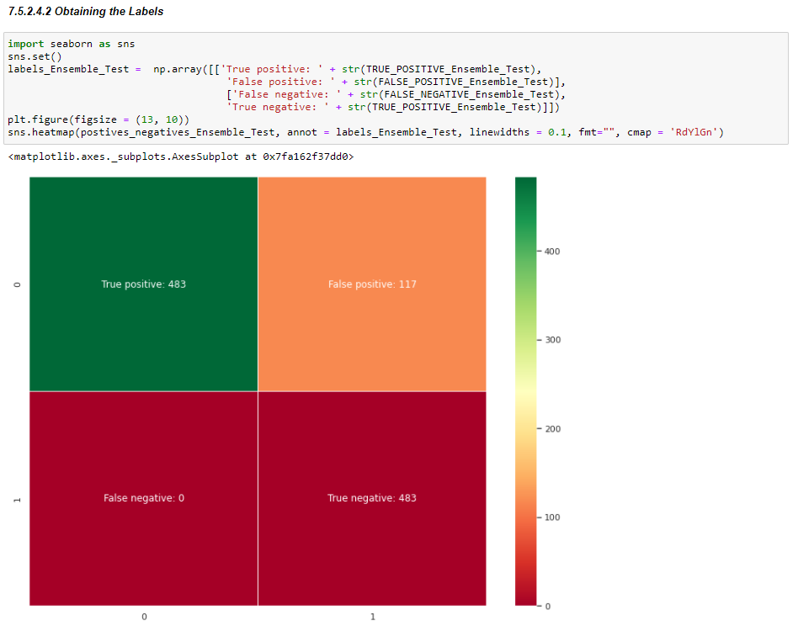

Figure 63: Project Demonstration - Evaluation of Models Together - Obtaining the Labels

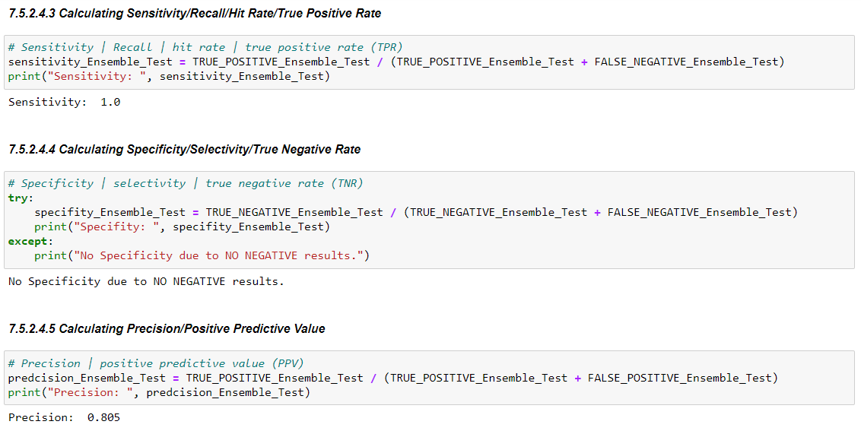

Figure 64: Project Demonstration - Evaluation of Models Together on Metrics(i)

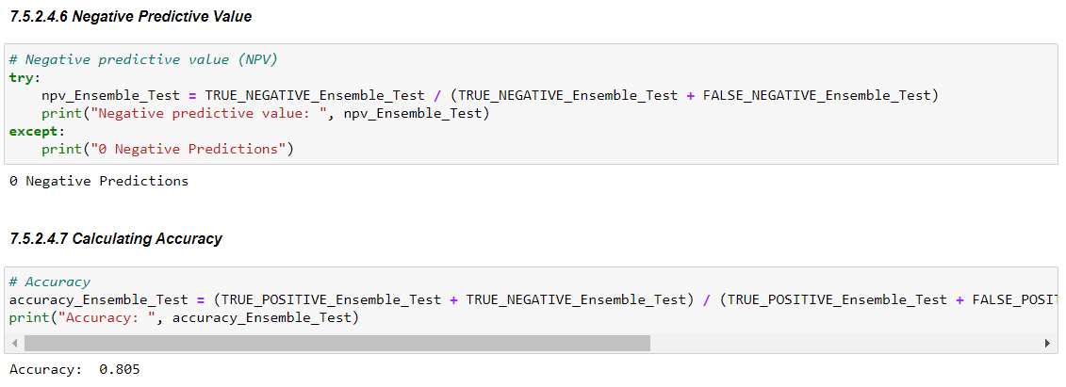

Figure 65: Project Demonstration - Evaluation of Models Together on Metrics(ii)

## Localization

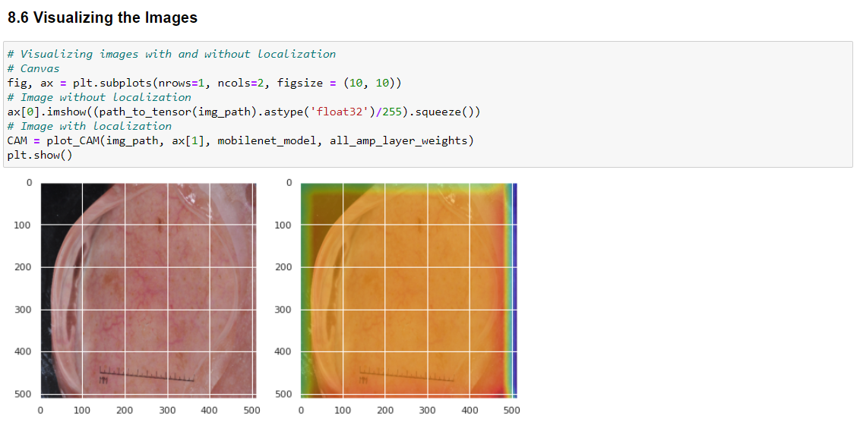

Figure 66: Project Demonstration - Localization - Visualizing Images

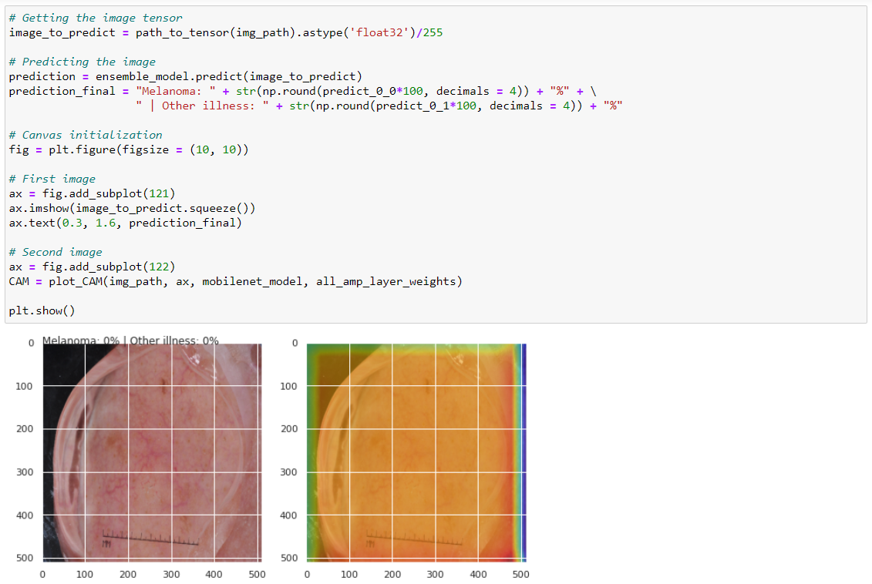

Figure 67: Project Demonstration - Localization - Display of Result

## Saving the Complete Model for Python Interface Application

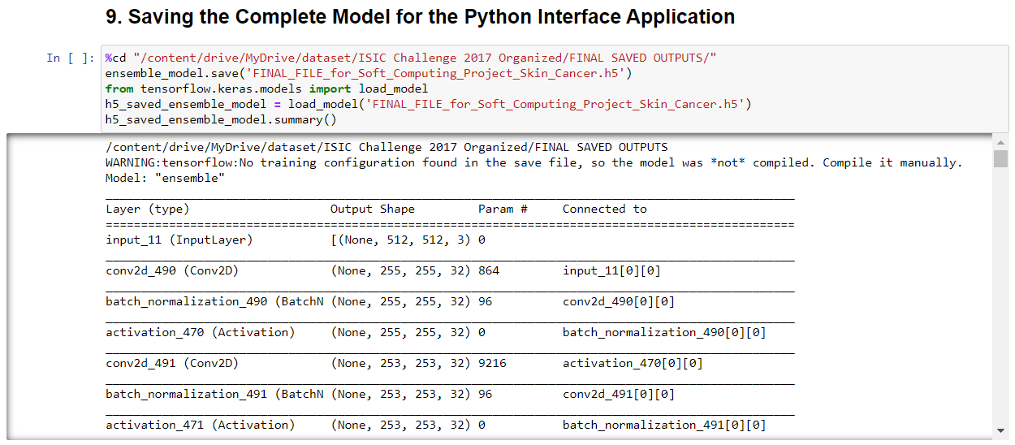

Figure 68: Project Demonstration - Saving the Model for Application Interface

## Converting the .h5 File to .tflite File for the Python Interface Application

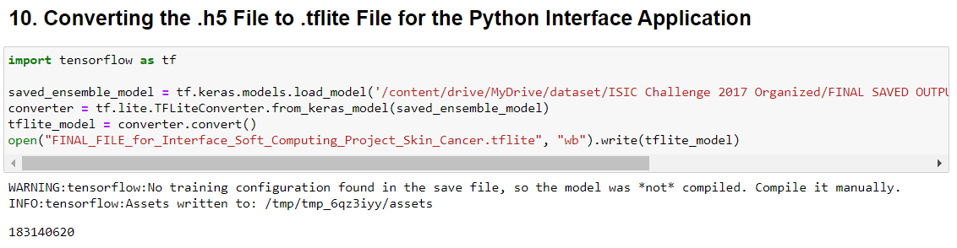

Figure 69: Project Demonstration - Converting the H5 File to TFLITE File

# Cost Analysis, Result and discussion

The project required to be subscribed to the Pro version of Google Colab which is on a Recurring Billing system and charges with $9.99/month excluding the taxes. The subscription was needed for 3 months which is the time period required for the project to complete.

# Summary

With the help of the model created with the help of Transfer Learning and Ensemble Modelling, we were able to achieve an accuracy of 80.5%. we have the results as:

|  |  |  |  |  |  |  |  |  |  |  |
| --- | --- | --- | --- | --- | --- | --- | --- | --- | --- | --- |
| Evaluation  Type | Architecture | Confusion Matrix | | | | Sensitivity/  Recall | Specificity | Precision | Negative Predictive Value | Accuracy |
| True Positive | False Positive | True Negative | False Negative |
| Evaluation of Individual Models on Validation Data | MobileNet | 120 | 30 | 0 | 0 | 1 | 0 | 0.8 | 0 | 0.8 |
| Inception | 120 | 30 | 0 | 120 | 1 | 0 | 0.8 | 0 | 0.8 |
| Xception | 120 | 30 | 0 | 120 | 1 | 0 | 0.8 | 0 | 0.8 |
| Evaluation of Ensemble Model on Validation Data | Ensemble Model | 120 | 30 | 0 | 120 | 1 | 0 | 0.8 | 0 | 0.8 |
| Evaluation of Individual Models on Testing Data | MobileNet | 483 | 117 | 0 | 0 | 1 | 0 | 0.805 | 0 | 0.805 |
| Inception | 483 | 117 | 0 | 483 | 1 | 0 | 0.805 | 0 | 0.805 |
| Xception | 483 | 117 | 0 | 483 | 1 | 0 | 0.805 | 0 | 0.805 |
| Evaluation of Ensemble Model on Testing Data | Ensemble Model | 483 | 117 | 0 | 483 | 1 | 0 | 0.805 | 0 | 0.805 |

# References

## Websites

* <https://www.analyticsvidhya.com/blog/2020/07/types-of-feature-transformation-and-scaling/>
* <https://towardsdatascience.com/detecting-and-treating-outliers-in-python-part-3-dcb54abaf7b0>
* <https://towardsdatascience.com/data-visualization-for-eda-exploratory-data-analysis-f001a1bf0087>
* <https://analyticsindiamag.com/exploratory-data-analysis-functions-types-tools/>
* <https://medium.com/mljcunito/the-last-step-in-data-preprocessing-handling-missing-values-ae8f19dae309>
* <https://www.kdnuggets.com/2020/07/easy-guide-data-preprocessing-python.html>

## Concepts & Information

* ResearchGate.com
* ScienceDirect.com
* GeeksforGeeks.com
* TutorialsPoint.com
* cs.stanford.edu
* Springer.com
* towardsdatascience.com
* academictorrents.com
* kaagle.com
* ncbi.nlm.nih.gov
* springml.com

## Research

* <https://www.researchgate.net/publication/334751850_Skin_Cancer_Detection_Using_Convolutional_Neural_Network>
* Peer-review under responsibility of the scientific committee of the 16th International Learning & Technology Conference 2019. 10.1016/j.procs.2019.12.090
* https://thesai.org/Publications/IJACSA
* <https://www.thelancet.com/journals/ebiom/article/PIIS2352-3964(19)30294-4/fulltext>

* <https://www.sciencedirect.com/science/article/pii/S2215016120300832?via%3Dihub>
* https://www.sciencedirect.com/science/article/pii/S1532046418301618?via%3Dihub
* https://www.ejcancer.com/article/S0959-8049(19)30381-8/fulltext
* https://www.researchgate.net/publication/335321267_Bio-Inspired_DeepCNN_Pipeline_for_Skin_Cancer_Early_Diagnosis
* https://www.researchgate.net/publication/347927500_Automated_Multiclass_Classification_of_Skin_Lesions_through_Deep_Convolutional_Neural_Network_with_Dermoscopic_Images
* https://www.researchgate.net/publication/339804392_Deep_Learning_Solutions_for_Skin_Cancer_Detection_and_Diagnosis?enrichId=rgreq-cc1ddabe639ba17298c595c27b48021c-XXX&enrichSource=Y292ZXJQYWdlOzMzOTgwNDM5MjtBUzo4ODM0MjE3NjUxNzMyNTFAMTU4NzYzNTU3MDg4Nw%3D%3D&el=1_x_3&_esc=publicationCoverPdf
* https://ieeexplore.ieee.org/document/9062473
* https://www.sciencedirect.com/science/article/pii/S0933365719301460
* https://papers.ssrn.com/sol3/papers.cfm?abstract_id=3352407
* https://www.researchgate.net/publication/335337495_A_CNN_toolbox_for_skin_cancer_classification?enrichId=rgreq-91f014447a4c29cec1b8c22e6f8930fb-XXX&enrichSource=Y292ZXJQYWdlOzMzNTMzNzQ5NTtBUzo4MDExNDUyMDMyMjQ1NzdAMTU2ODAxOTMwOTE5Nw%3D%3D&el=1_x_3&_esc=publicationCoverPdf
* https://ieeexplore.ieee.org/document/8720210
* https://www.ncbi.nlm.nih.gov/pmc/articles/PMC6231861/
* https://iopscience.iop.org/article/10.1088/1757-899X/982/1/012005
* https://www.researchgate.net/publication/327539277_Skin_Cancer_Classification_using_Convolutional_Neural_Networks_Systematic_Review_Preprint
* https://www.sciencedirect.com/science/article/pii/S2352914819302047
* https://www.researchgate.net/publication/334123580_Melanoma_Skin_Cancer_Detection_using_Image_Processing_and_Machine_Learning
* https://www.nature.com/articles/nature21056
* https://ieeexplore.ieee.org/stamp/stamp.jsp?tp=&arnumber=9113301
* <https://pubmed.ncbi.nlm.nih.gov/28117445/>
* https://pubmed.ncbi.nlm.nih.gov/30333097/
* https://ieeexplore.ieee.org/document/9198489